# A project report on:

# 

# Big Data Analysis for Telecommunications

# 

Contents

A project report on: 1

1

Big Data Analysis for Telecommunications 1

Big Data Analysis for Telecommunications 5

Abstract 5

Introduction 5

1.1 Background and Motivation 5

1.2 Problem Statement 6

1.3 Objectives of the Study 6

1.4 Scope of the Study 7

1.5 Significance of the Study 7

2. Literature Review 8

2.1 Big Data in Telecommunications 8

Applications of Big Data in Telecommunications 8

2.2 Machine Learning for Telecommunications 9

Supervised Learning for Telecommunications 9

Unsupervised Learning for Telecommunications 9

Deep Learning for Telecommunications 13

2.3 Tools and Frameworks for Big Data Analytics in Telecommunications 15

PySpark for Big Data Processing 18

Hadoop & Spark for Distributed Data Processing 18

Python & R for Data Analysis and Machine Learning 18

Cloud Platforms and Big Data Storage 18

3. Methodology 19

4. Data Collection and Processing 20

1. Handling Missing Values 20

Types of Missing Data 20

Imputation Techniques Used 20

2. Encoding Categorical Variables 21

2.1 String Indexing 21

2.2 One-Hot Encoding 21

3. Standardization of Numerical Features 22

StandardScaler for Normalization 22

Why Standardization Is Important? 23

4. Data Splitting: Training and Testing 23

Why Use an 80-20 Split? 23

Stratified Sampling 23

5. Exploratory Data Analysis (EDA) for Customer Churn Prediction 24

5.1 Distribution of Churn Rates 24

Analysis of Churn Distribution 25

Impact of Churn Distribution on Model Training 25

5.2 Correlation Between Customer Behavior and Churn 25

Understanding Correlation 25

Key Correlation Insights in Telecommunications Churn 25

Significance of Correlation Analysis 26

5.3 Feature Importance in Random Forest 26

Why Use Random Forest for Feature Importance? 26

Key Feature Importance Insights from Random Forest 27

Advantages of Using Random Forest for Feature Selection 27

Business Implications of Feature Importance Analysis 27

6. Machine Learning Model Development 30

1. Random Forest Classifier 30

Working Principle 30

Rationale for Selection 30

Training on Telecom Churn Data 30

2. Logistic Regression 31

Working Principle 31

Rationale for Selection 31

Training on Telecom Churn Data 32

3. Decision Tree Classifier 32

Working Principle 32

Rationale for Selection 33

Training on Telecom Churn Data 33

4. Gradient Boosted Trees (GBT) 33

Working Principle 33

Rationale for Selection 34

Training on Telecom Churn Data 34

1. Accuracy 35

2. Precision 35

3. Recall 36

4. F1 Score 36

Why These Metrics Are Important for Churn Prediction 37

7. Performance Evaluation 38

8. Insights and Recommendations **Error! Bookmark not defined.**

9. Conclusion 46

Future Research Directions 47

10. References 47

Academic References 47

Industry Reports & White Papers 59

# Big Data Analysis for Telecommunications

## Abstract

The rapid expansion of telecommunications networks and the increasing volume of data generated by users, devices, and infrastructure have necessitated the adoption of advanced analytical techniques to enhance operational efficiency and decision-making. This study explores the application of big data analytics in the telecommunications sector, with a focus on network management, customer service enhancement, and strategic decision-making.

The research employs machine learning algorithms, such as Random Forest, Logistic Regression, Decision Trees, and Gradient Boosted Trees, to analyze large-scale telecommunications data. The dataset comprises network usage records, customer interactions, and operational metrics, which are processed using big data frameworks like Apache Spark. The data undergoes extensive preprocessing, including cleaning, feature engineering, and transformation, to ensure high-quality inputs for predictive modeling.

A series of machine learning models are trained and evaluated based on key performance metrics such as accuracy, precision, recall, and F1-score. The study highlights the effectiveness of these models in various applications, including churn prediction, network failure detection, and customer segmentation. Additionally, feature importance analysis provides insights into the most influential factors affecting telecommunications performance and customer retention.

The findings of this research contribute to the growing field of data-driven telecommunications management, demonstrating how big data analytics can enhance network reliability, optimize resource allocation, and improve customer retention strategies. The report also discusses challenges such as data scalability, privacy concerns, and computational complexity, providing recommendations for future research and industry applications.

This study serves as a valuable resource for telecommunications companies seeking to harness the power of big data to drive operational improvements and maintain a competitive edge in an increasingly data-intensive industry.

# ****Introduction****

## ****1.1 Background and Motivation****

The telecommunications industry is a critical pillar of modern digital infrastructure, facilitating global communication, data exchange, and business operations. With the rapid expansion of mobile networks, internet services, and digital platforms, telecommunications companies generate and manage enormous volumes of data daily. This data includes call records, network logs, service usage patterns, customer interactions, billing information, and system performance metrics. Effectively leveraging this data is essential for improving service quality, optimizing network performance, enhancing customer satisfaction, and maintaining competitive advantage in an increasingly dynamic industry.

Big Data analytics has emerged as a transformative approach to processing, analyzing, and interpreting large-scale telecommunications data. By applying advanced analytical techniques, telecommunications companies can extract meaningful patterns, predict customer behavior, detect network failures, and optimize operational efficiency. The ability to analyze vast datasets in real time allows telecom providers to proactively manage network congestion, identify potential security threats, reduce operational costs, and personalize customer experiences.

Machine learning, a subset of artificial intelligence, plays a crucial role in big data analytics by enabling automated pattern recognition, predictive modeling, and intelligent decision-making. In the telecommunications sector, machine learning algorithms can be used to analyze customer churn, detect fraudulent activities, forecast network failures, and optimize resource allocation. This study focuses on the application of machine learning techniques to analyze key challenges in the telecommunications industry, such as customer churn prediction, network performance optimization, and service quality enhancement.

## ****1.2 Problem Statement****

The telecommunications industry faces several challenges related to network reliability, customer retention, and service optimization. These challenges arise due to the growing complexity of network infrastructure, increasing customer demands, and the need for efficient resource management. Some of the key issues addressed in this study include:

* **Customer Churn Prediction:** Customer attrition (churn) is a major concern for telecom providers, as retaining existing customers is more cost-effective than acquiring new ones. Identifying factors that contribute to churn and predicting potential churners using machine learning models can help companies implement targeted retention strategies.
* **Network Performance Analysis:** Ensuring high network availability and performance is crucial for customer satisfaction. Machine learning models can analyze network logs to detect anomalies, predict failures, and optimize traffic management.
* **Service Optimization:** By analyzing customer usage patterns and feedback, telecom providers can personalize services, recommend suitable plans, and improve service delivery. Data-driven insights enable dynamic pricing, proactive maintenance, and resource allocation strategies.

This study aims to develop and evaluate machine learning models that address these challenges, leveraging big data analytics to improve decision-making in the telecommunications sector.

## ****1.3 Objectives of the Study****

The primary objectives of this research are:

1. **To explore the role of big data analytics in telecommunications** – Understanding how large-scale data can be processed, analyzed, and utilized to improve telecom operations.
2. **To develop machine learning models for key telecom applications** – Implementing predictive analytics for customer churn, network failures, and service optimization.
3. **To evaluate model performance and feature importance** – Assessing different machine learning algorithms based on performance metrics such as accuracy, precision, recall, and F1-score.
4. **To provide actionable insights for telecom companies** – Identifying key factors affecting customer retention, network stability, and service quality, and recommending data-driven strategies.

## ****1.4 Scope of the Study****

This study focuses on analyzing telecommunications data using big data analytics and machine learning techniques. The scope includes:

* **Data Sources:** The study utilizes customer records, network performance logs, and service usage data from telecommunications providers.
* **Machine Learning Models:** Various classification models, including Random Forest, Logistic Regression, Decision Trees, and Gradient Boosted Trees, are used for predictive analytics.
* **Data Processing Techniques:** Preprocessing steps such as data cleaning, feature engineering, categorical encoding, and standardization are applied to ensure model efficiency.
* **Performance Evaluation:** The models are evaluated based on metrics such as accuracy, precision, recall, and F1-score to determine their effectiveness.
* **Visualization and Interpretation:** Data insights are presented using statistical summaries, correlation analysis, feature importance rankings, and graphical visualizations.

## ****1.5 Significance of the Study****

This research provides valuable insights into how big data analytics and machine learning can revolutionize telecommunications operations. The key contributions include:

* **Enhancing Customer Retention Strategies:** By predicting churn, telecom providers can take proactive measures to improve customer satisfaction and reduce attrition rates.
* **Optimizing Network Performance:** Predictive analytics enables telecom companies to anticipate network failures, reduce downtime, and enhance service quality.
* **Improving Decision-Making:** Data-driven insights empower telecom executives to make informed strategic decisions regarding pricing, marketing, and resource allocation.
* **Advancing the Application of Machine Learning in Telecommunications:** The study demonstrates the potential of AI-driven approaches in addressing telecom industry challenges.

This study aims to bridge the gap between theoretical advancements in machine learning and their practical implementation in telecommunications, providing a comprehensive roadmap for leveraging big data analytics to optimize telecom operations.

# ****2. Literature Review****

## ****2.1 Big Data in Telecommunications****

The role of big data in the telecommunications sector has evolved significantly in recent years, transforming how companies manage their networks, improve customer service, and make strategic decisions. Telecommunications companies generate vast amounts of data daily, including call records, internet usage logs, service quality metrics, and customer interactions. Traditional methods of data processing and analysis are often insufficient to handle such high-volume, high-velocity, and high-variety datasets. This has led to the adoption of **big data analytics**, which enables real-time insights, predictive modeling, and data-driven decision-making.

### ****Applications of Big Data in Telecommunications****

1. **Network Performance Monitoring and Optimization**
   * Telecommunication networks are complex systems that require continuous monitoring to ensure seamless connectivity and service quality. Big data analytics enables **real-time monitoring of network performance**, detecting anomalies such as congestion, dropped calls, or service disruptions.
   * Machine learning models can **predict network failures** before they occur, allowing proactive maintenance and reducing downtime. Predictive analytics also helps in **capacity planning**, ensuring that networks can scale efficiently to meet demand.
2. **Fraud Detection and Prevention**
   * Fraud is a significant issue in the telecommunications industry, including **SIM cloning, identity theft, call spoofing, and subscription fraud**. Big data analytics enables companies to identify suspicious activity patterns using machine learning techniques.
   * Supervised learning models (e.g., Random Forest, Logistic Regression) can **classify fraudulent vs. legitimate transactions**, while unsupervised methods (e.g., clustering) can **detect unusual patterns** in call or usage data.
3. **Customer Experience and Retention (Churn Prediction)**
   * Customer churn, or the loss of subscribers to competitors, is a major concern for telecom companies. By leveraging big data analytics, companies can **analyze customer behavior, identify churn risk factors, and implement targeted retention strategies**.
   * Machine learning models can predict churn likelihood based on features such as **call drop frequency, billing disputes, service complaints, and usage patterns**. Companies can then personalize offers and improve service quality to retain at-risk customers.
4. **Revenue Optimization and Dynamic Pricing**
   * Telecom companies use big data analytics to **analyze market trends, customer preferences, and service usage patterns** to optimize pricing models.
   * Predictive analytics helps companies introduce **dynamic pricing** based on demand fluctuations, competition, and customer segments.
5. **Personalized Marketing and Customer Segmentation**
   * Analyzing customer preferences allows telecom providers to **offer personalized plans, discounts, and promotions**.
   * Unsupervised learning techniques such as clustering help in **customer segmentation**, allowing better targeting of marketing campaigns.

## ****2.2 Machine Learning for Telecommunications****

Machine learning has become an integral part of big data analytics in the telecommunications industry. By leveraging machine learning techniques, telecom companies can analyze large datasets to gain insights, make accurate predictions, and optimize various operations.

### ****Supervised Learning for Telecommunications****

Supervised learning is widely used in the telecom industry for predictive modeling, where labeled data is available for training.

### 1. ****Customer Churn Prediction****

Customer churn prediction is a critical application of supervised learning in the telecom industry, helping companies identify customers who are likely to leave and take proactive measures to retain them. By using labeled data (e.g., whether a customer churned or not), predictive models can forecast churn risk and guide business decisions.

* **Classification Algorithms for Churn Prediction**:
  + **Random Forest**: Random Forest is an ensemble learning method that constructs multiple decision trees during training and outputs the class that is the mode of the classes (classification) or mean prediction (regression) of the individual trees. Random Forest is effective for churn prediction because it handles high-dimensional data (i.e., data with many features like billing history, usage data, customer complaints, etc.) and captures complex non-linear relationships. It is also resistant to overfitting, making it ideal for large datasets in telecom.
  + **Logistic Regression**: Logistic Regression is a simpler yet highly interpretable method used for binary classification problems like churn prediction (yes/no). It works by estimating the probability of a customer churning based on a set of features, using a logistic function to model the relationship between independent variables (e.g., call frequency, service usage) and the probability of churn. This model is particularly useful for understanding the influence of specific features (e.g., how customer complaints correlate with churn).
  + **Decision Trees**: Decision Trees are easy to interpret and visualize, making them popular in telecom for churn prediction. A decision tree splits the data based on feature values (such as "high usage" or "complaints received") to predict the likelihood of a customer churning. While decision trees can overfit if not properly tuned, they can be powerful when combined with pruning or ensemble methods like Random Forest.
  + **Gradient Boosted Trees (GBT)**: Gradient Boosting is an ensemble technique that builds multiple decision trees sequentially, where each tree tries to correct the errors of the previous one. It has become one of the most powerful methods for churn prediction because it improves predictive accuracy by iteratively optimizing the model. GBTs can handle imbalanced datasets and complex relationships between features, making them ideal for telecom churn prediction, where certain features might be more influential than others.
* **Analyzing Historical Customer Data**: These models analyze **historical data** such as:
  + **Billing History**: Patterns in payment timeliness, payment amounts, and payment failures often signal potential churn risk.
  + **Service Usage**: Changes in usage patterns (e.g., decrease in data consumption, fewer calls made) can indicate declining customer satisfaction.
  + **Customer Complaints**: A customer who has filed multiple complaints or is dissatisfied with the service is more likely to churn.
  + **Network Quality Metrics**: Poor network quality, such as frequent call drops, slow data speeds, or outages, significantly increases the likelihood of customer churn.
* **Implementation with PySpark**: In this study, we used **PySpark**, a powerful framework for distributed data processing and large-scale machine learning, to implement these models. PySpark allows us to handle massive datasets efficiently, enabling the training of models on vast customer datasets typical in the telecom industry. By leveraging PySpark's MLlib library, we can implement Random Forest, Logistic Regression, Decision Trees, and Gradient Boosted Trees at scale, enabling telecom companies to predict churn more accurately and in real-time.

### 2. ****Fraud Detection and Anomaly Detection****

Fraud detection in the telecom industry involves identifying unusual patterns of behavior that might indicate fraudulent activity, such as unauthorized use of services or subscription fraud. Supervised learning techniques are widely applied to differentiate between normal and fraudulent transactions.

* **Classification Algorithms for Fraud Detection**:
  + **Random Forest**: As an ensemble method, Random Forest is particularly useful in fraud detection because it can handle imbalanced datasets (i.e., where fraudulent activities are rare compared to normal activities). It combines multiple decision trees to improve prediction accuracy and reduce overfitting. In fraud detection, Random Forest analyzes patterns of behavior and flags transactions that deviate from normal behavior, such as irregular call patterns or abnormal spending behavior.
  + **Gradient Boosting Machines (GBM)**: GBMs are another ensemble technique that builds models sequentially to correct errors in previous models. They are highly effective for fraud detection because they can capture complex, non-linear relationships between features and improve prediction performance. In telecom, GBMs can help detect fraud by identifying patterns like unusual peak usage times, sudden changes in call destinations, or abnormal usage patterns.
  + **Support Vector Machines (SVMs)**: SVMs are powerful classification algorithms that work well for identifying boundaries between classes (e.g., fraud vs. non-fraud). SVMs are particularly useful when there is a clear margin of separation between the classes. In fraud detection, SVMs can classify transactions as fraudulent based on patterns in customer behavior, such as sudden surges in usage, international roaming, or multiple SIM card activations in a short period.
* **Detecting Fraudulent Transactions**: The algorithms detect fraud by analyzing various behavioral attributes such as:
  + **Usage Patterns**: Sudden, unexplained increases in call duration or data usage can be indicative of fraud, especially if the usage doesn't align with the customer’s normal behavior.
  + **Location Data**: Telecom fraud often involves using services in locations where the user has never been before, or at times when they are normally inactive.
  + **Account Activity**: Multiple failed login attempts or the creation of multiple accounts under the same name or address can trigger fraud alerts.
  + **Unusual Call Behavior**: Fraudulent behavior often involves making calls to unusual or international destinations that differ from normal patterns. These anomalies are flagged for review.
* **Improving Fraud Detection with Ensemble Models**: Ensemble models, such as Random Forest and GBM, are effective in fraud detection because they aggregate multiple weak learners to create a robust model that performs better than individual models. The diversity of decision trees or weak learners in these ensemble models helps detect various types of fraudulent activity, improving the overall accuracy of fraud detection systems.

### 3. ****Network Failure Prediction****

Predicting network failures and outages is essential for ensuring high service availability and customer satisfaction. By forecasting which components of the network are most likely to fail, telecom companies can perform proactive maintenance and minimize downtime.

* **Predicting Network Failures Using Machine Learning**:
  + **Historical Network Data**: Machine learning models can be trained on network logs and historical failure data to identify patterns or features that typically precede network failures. For example, certain network events like high traffic, unusual packet loss, or spikes in CPU usage might correlate with an increased likelihood of network failure.
  + **Components Likely to Fail**: Machine learning models can analyze data from various network components (routers, switches, servers, etc.) to predict which are more prone to failures. For example, a component might be more likely to fail if it has reached a certain threshold of usage or if it has a history of intermittent issues.
* **Supervised Learning Algorithms for Failure Prediction**:
  + **Random Forest**: Random Forest can analyze large datasets of network logs and identify complex interactions between features (such as hardware utilization, traffic patterns, and error rates) that correlate with network failures. It can also handle noisy data, which is common in network performance logs.
  + **Logistic Regression**: Logistic Regression models can predict the probability of network failure by evaluating factors like system health metrics, historical failures, and maintenance schedules. This can be useful for predicting which network components are at risk of failure in the near future.
  + **Gradient Boosted Machines**: GBMs are effective for failure prediction because they can iteratively improve predictions by correcting errors in previous models. By capturing the relationship between numerous network performance features and failure events, GBMs can help predict when specific components are likely to fail, allowing for targeted preventative maintenance.
* **Real-Time Monitoring for Network Health**: Using these supervised learning models, telecom companies can set up real-time monitoring systems that continuously evaluate the health of the network. These systems can predict failures before they occur, enabling technicians to perform preventive maintenance, replace aging equipment, or reroute traffic to avoid network disruptions.

### ****Unsupervised Learning for Telecommunications****

Unsupervised learning techniques help identify patterns in data where labels are not available.

### 1. ****Customer Segmentation****

Unsupervised learning techniques such as clustering are essential for uncovering hidden patterns in data when labels are not available. By grouping customers with similar behaviors or characteristics, telecom companies can provide more targeted services, improve customer retention, and optimize marketing efforts.

* **K-Means Clustering, Hierarchical Clustering, and DBSCAN for Customer Segmentation**:
  + **K-Means Clustering**: This is one of the most widely used clustering techniques in customer segmentation. K-Means works by partitioning data into K clusters based on feature similarities. In the telecom industry, K-Means can be used to cluster customers based on factors like usage patterns (e.g., data consumption, call frequency), payment behavior (e.g., high-value customers, low-value customers), and even geographic location. Telecom companies can use K-Means to divide their customer base into distinct segments, which helps tailor marketing and pricing strategies.
  + **Hierarchical Clustering**: Unlike K-Means, which requires the number of clusters to be predefined, hierarchical clustering builds a tree of clusters that can be used to understand customer relationships in a more flexible way. It can be particularly useful when the optimal number of clusters is not known beforehand. This technique can help telecom companies identify subgroups of customers within broader categories, such as identifying a high-value subset of frequent users or understanding the needs of customers with similar service preferences.
  + **DBSCAN (Density-Based Spatial Clustering of Applications with Noise)**: DBSCAN is a density-based clustering algorithm that is particularly effective for data with noise and outliers. It does not require a pre-specified number of clusters and can detect clusters of arbitrary shapes. DBSCAN can be particularly useful for identifying customer groups with very specific and rare behaviors, such as users who might exhibit unusual patterns of data usage that don't fit traditional segmentation models.
* **Customer Segmentation Using Behavioral Data**: By applying these clustering techniques, telecom companies can segment customers based on a wide range of factors:
  + **Usage Patterns**: This includes metrics such as call frequency, data usage, and internet browsing habits. By segmenting based on usage, telecom providers can identify heavy users who may require premium data plans or light users who could be offered basic packages.
  + **Geographic Location**: Customers can be segmented by location, which helps in designing region-specific offers or promotions, especially if some areas face network congestion or offer different service levels.
  + **Spending Behavior**: Clustering customers based on how much they spend or how frequently they make payments can identify high-value customers or those who may be at risk of churning.
  + **Service Preferences**: Customers might be segmented based on their preferences for specific telecom services, such as mobile broadband, voice services, or bundled packages. This enables telecom companies to offer personalized plans or targeted offers.
* **Personalized Offers and Targeted Marketing**: The results of these customer segments enable telecom companies to create more effective and personalized marketing campaigns. For example, if a segment of customers is identified as price-sensitive, they can be offered discounts or budget-friendly packages. Alternatively, high-value customers might receive loyalty rewards or exclusive offers. Moreover, by understanding the preferences and behavior of different segments, telecom companies can improve customer satisfaction and increase retention rates.

### 2. ****Anomaly Detection in Network Traffic****

Unsupervised learning techniques like anomaly detection are crucial for identifying irregular patterns or behaviors that may indicate problems or threats within a network. This is especially important for maintaining network security and ensuring the efficient operation of telecom infrastructure.

* **Autoencoders and Principal Component Analysis (PCA) for Anomaly Detection**:
  + **Autoencoders**: Autoencoders are a type of neural network that is used to learn a compressed, efficient representation of the input data. They are particularly effective for anomaly detection because they can reconstruct network traffic data. When used for anomaly detection, the model is trained on normal traffic patterns. If the network encounters a traffic pattern that differs significantly from what the autoencoder has learned, the reconstruction error will be high, indicating an anomaly. This could signal issues like unexpected network congestion, unauthorized access, or a sudden surge in data usage. Autoencoders are powerful because they learn data representations automatically and do not require labeled data.
  + **Principal Component Analysis (PCA)**: PCA is a statistical technique used to reduce the dimensionality of data by transforming it into a smaller set of uncorrelated variables (principal components). In network traffic analysis, PCA can be applied to detect anomalies by identifying outliers in the data. When network traffic deviates from typical patterns, it can appear as an outlier in the lower-dimensional space defined by PCA. Telecom providers can use PCA to monitor network health and detect unusual patterns such as traffic spikes, failures, or even cyber-attacks. Additionally, PCA is valuable when the volume of data is high, as it helps reduce computational complexity while preserving most of the variability in the data.
* **Anomalous Traffic Patterns Indicating Issues**:
  + **Cybersecurity Threats**: Unusual network activity, such as a large number of failed login attempts, unusual data transfers, or traffic from unrecognized IP addresses, can indicate a potential cyberattack, such as a Distributed Denial of Service (DDoS) attack or intrusion attempts. Anomaly detection algorithms can automatically flag these suspicious behaviors for further investigation.
  + **Unauthorized Access**: Network traffic anomalies can indicate unauthorized access to sensitive resources, such as hacking attempts or the use of stolen credentials. Unusual patterns, like access from a new geographical location or unusual data requests, can be automatically detected using unsupervised anomaly detection methods.
  + **Unusual Usage Behavior**: Sometimes, unexpected usage patterns might arise from legitimate but unusual customer activity, such as data-hungry applications or changes in usage behavior. These anomalies might indicate that a user has changed their service habits, such as using more data or making more international calls. Identifying these changes can help telecom providers understand shifting customer behavior or detect issues like data plan abuse or fraudulent activity.
* **Real-Time Monitoring**: Unsupervised anomaly detection is especially valuable in real-time network monitoring. It allows telecom providers to detect problems as they happen and take immediate corrective action, such as rerouting traffic, blocking malicious traffic, or notifying security teams. This approach improves overall network reliability and helps prevent costly downtime or breaches.

### ****Deep Learning for Telecommunications****

Deep learning models such as **Artificial Neural Networks (ANNs) and Convolutional Neural Networks (CNNs)** are increasingly being applied in telecom analytics.

### 1. ****Predictive Maintenance****

Predictive maintenance uses deep learning models to anticipate potential issues with network infrastructure, allowing telecom companies to reduce downtime and improve service reliability. The idea is to predict when a piece of hardware is likely to fail, allowing for timely repairs and replacements.

* **Neural Networks for Hardware Failure Prediction**: Neural networks can be used to analyze historical data from various network components (routers, servers, cables, etc.). By training on data like temperature, network traffic, error rates, and usage patterns, neural networks can identify complex relationships and predict the likelihood of hardware failures before they happen. This minimizes unplanned outages and optimizes resource allocation for repairs.
* **Recurrent Neural Networks (RNNs) and Long Short-Term Memory (LSTMs) for Time-Series Analysis**: Network systems generate large amounts of sequential data over time. RNNs and LSTMs, which are specialized types of neural networks for handling sequential data, excel in forecasting future events based on past observations.
  + **RNNs**: These networks are designed to remember the temporal dynamics in the data. However, they can suffer from the "vanishing gradient problem," making them less effective over long sequences.
  + **LSTMs**: LSTMs are a specific kind of RNN that solve the vanishing gradient problem by using memory cells to store information over long periods. This makes them ideal for time-series forecasting of network failures, as they can learn patterns over extended timeframes. These models can be applied to predict when hardware might fail, based on patterns such as unusual system load, degraded performance, or anomalous traffic behavior, allowing telecom providers to schedule maintenance activities ahead of time.

### 2. ****Natural Language Processing (NLP) for Customer Support****

Deep learning-based NLP techniques are revolutionizing customer support operations by enabling telecom companies to interact with customers in a more automated and efficient way.

* **Chatbots and Virtual Assistants Powered by NLP**: Telecom companies have begun to deploy chatbots and virtual assistants to handle common customer inquiries, troubleshoot issues, and provide 24/7 support. These systems are powered by deep learning models trained on vast amounts of conversational data, allowing them to understand and respond to customer queries accurately and naturally.
  + **Transformers**: Deep learning models like GPT (Generative Pre-trained Transformer) and BERT (Bidirectional Encoder Representations from Transformers) are among the most powerful models for NLP. These models have revolutionized how machines understand and generate human language.
  + **Application in Telecom**: Chatbots in telecom might handle tasks like checking data usage, resolving billing issues, or troubleshooting network outages. These systems are continually improved by fine-tuning with new conversational data, leading to more accurate and context-aware responses.
* **Sentiment Analysis on Customer Feedback**: By applying NLP models, telecom providers can gain valuable insights from customer feedback. Sentiment analysis techniques can classify customer interactions (such as emails, call center transcripts, or social media posts) as positive, negative, or neutral, and even detect specific emotions (like frustration or satisfaction).
  + **Understanding Customer Sentiment**: By analyzing customer sentiment, telecom companies can better gauge the effectiveness of their services and address areas where customers might be dissatisfied, such as network issues, customer service problems, or pricing concerns. For example, sentiment analysis can help identify customers who may be at risk of churn based on their negative feedback, allowing the company to take proactive measures.
  + **Improving Customer Service**: NLP-based sentiment analysis not only helps in identifying customer dissatisfaction but can also assist in measuring overall customer satisfaction and sentiment over time. Telecom companies can use this data to improve services, develop better products, or refine their customer support strategies to enhance user experience.

### Additional Applications of Deep Learning in Telecom:

1. **Network Traffic Prediction and Optimization**
   * **Traffic Forecasting with LSTMs and Deep Neural Networks (DNNs)**: Telecom companies often face fluctuating network traffic due to varying demand patterns, such as peak usage during certain times of the day or events. Deep learning models, especially LSTMs and DNNs, can be used to forecast traffic patterns, helping to manage congestion, optimize load balancing, and allocate resources efficiently. By predicting traffic surges, telecom companies can preemptively scale their network infrastructure and allocate bandwidth to meet demand.
2. **Fraud Detection**
   * **Anomaly Detection Using Autoencoders**: Fraud detection is another area where deep learning can add value. Deep learning models, such as autoencoders, can be used to detect anomalies in network traffic or user behavior. For example, if a subscriber suddenly makes unusually high international calls or engages in suspicious activity, an autoencoder model can flag this behavior as abnormal. Such systems can identify fraudulent activities like SIM card cloning, unauthorized usage, or billing fraud in real-time.
3. **Network Quality Monitoring**
   * **CNNs for Image and Video Analysis**: Deep learning models like Convolutional Neural Networks (CNNs), typically used in image processing, can also be applied to network quality monitoring. By analyzing visual data (e.g., images from network cameras or satellite data), CNNs can help monitor network infrastructure, detect physical damage, or identify problems such as cable cuts, hardware damage, or infrastructure degradation.
   * **Deep Learning for Predictive Monitoring**: CNNs can also be used to analyze real-time sensor data from network infrastructure, such as monitoring signal strength or data packet loss. The deep learning models can learn patterns associated with network issues and trigger alerts when specific thresholds are exceeded.

## ****2.3 Tools and Frameworks for Big Data Analytics in Telecommunications****

Big data analytics requires robust tools and frameworks capable of handling large volumes of structured and unstructured data. The following are the key tools used in this study:

### ****PySpark for Big Data Processing****

* This study **utilized PySpark**, a Python API for Apache Spark, to process and analyze large telecommunications datasets efficiently.
* **Advantages of PySpark in this study:**
  + **Distributed processing:** Handles massive datasets by distributing computations across multiple nodes.
  + **In-memory computing:** Enables faster execution compared to traditional disk-based processing.
  + **Seamless integration with machine learning libraries:** Includes MLlib, Spark’s built-in machine learning library, for scalable model training.

### ****Hadoop & Spark for Distributed Data Processing****

* **Apache Hadoop** provides a distributed file system (HDFS) for storing vast amounts of telecommunications data.
* **Apache Spark** is a powerful alternative to Hadoop’s MapReduce framework, offering improved speed and flexibility.
* **Spark Streaming** enables **real-time data processing**, crucial for applications like **network monitoring and fraud detection**.

### ****Python & R for Data Analysis and Machine Learning****

* **Python** was used in this study for **data preprocessing, machine learning, and visualization**. Key Python libraries include:
  + **Pandas & NumPy** – Data manipulation and numerical computing.
  + **Matplotlib & Seaborn** – Data visualization.
  + **Scikit-learn** – Machine learning model development.
  + **PySpark MLlib** – Scalable machine learning on distributed data.
* **R** is another powerful tool for statistical computing and visualization, although it was not the primary tool in this study.

### ****Cloud Platforms and Big Data Storage****

* **Amazon Web Services (AWS), Google Cloud Platform (GCP), and Microsoft Azure** offer cloud-based big data solutions, enabling scalable storage and computing resources.
* **Databases such as Apache Hive and HBase** are used for structured data storage, while **NoSQL databases like MongoDB** handle unstructured telecommunications data.

## 3. Methodology

This study follows a structured approach:

1. Data acquisition from telecommunications networks.
2. Data cleaning and preprocessing.
3. Exploratory data analysis for trend identification.
4. Machine learning model training and evaluation.
5. Interpretation of results and business insights.

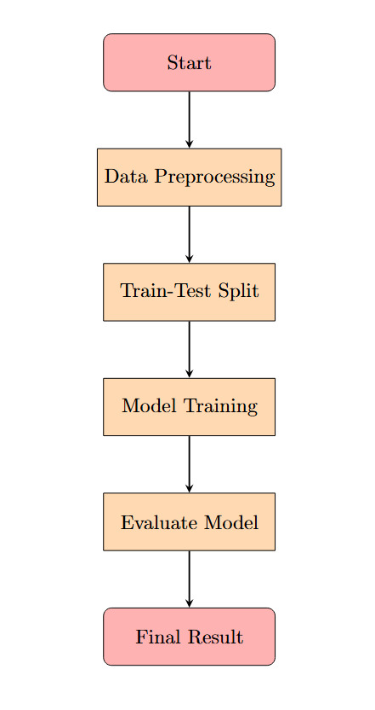

### ****4. Data Collection and Processing****

This study utilizes telecommunications data, including **Call Detail Records (CDR)** for customer interactions, **network logs** for performance metrics, and **customer demographics** for subscription patterns. The dataset was loaded using **PySpark** for efficient big data processing.

Data source from where collect Data is kaggle plateform.

Data source link is given:

https://www.kaggle.com/datasets/spscientist/telecom-data

#### ****Data Preprocessing:****

* **Handling Missing Values:** Identified and imputed missing data using statistical methods.
* **Encoding Categorical Variables:** Applied **String Indexing** and **One-Hot Encoding** to convert categorical data into numerical form.
* **Standardization of Numerical Features:** Used **StandardScaler** to normalize numerical data.
* **Data Splitting:** Divided the dataset into **80% training** and **20% testing** for machine learning models.

## ****1. Handling Missing Values****

Missing values in a dataset can significantly impact machine learning models by introducing biases or reducing predictive accuracy. In this study, missing values were identified and addressed using statistical imputation techniques.

### ****Types of Missing Data****

* **Missing Completely at Random (MCAR)**: Data is missing with no relation to any other variable or the missing values themselves.
* **Missing at Random (MAR)**: The probability of missingness depends on observed data but not on the missing values themselves.
* **Missing Not at Random (MNAR)**: The missing values depend on unobserved data, making imputation challenging.

### ****Imputation Techniques Used****

1. **Mean/Median Imputation**: For numerical features, missing values were replaced with the mean or median of the column to maintain the central tendency of the data. Median imputation was preferred for skewed data distributions.
2. **Mode Imputation**: For categorical features, missing values were replaced with the most frequent category (mode), ensuring minimal disruption to data patterns.
3. **Forward/Backward Fill**: For time-series data, missing values were filled using forward or backward propagation based on past observations.
4. **Dropping Missing Values**: In cases where missing values were excessive (e.g., >30% of a column), the affected records or features were removed to avoid introducing noise.

These techniques ensured that no significant information was lost while maintaining data integrity and consistency.

## ****2. Encoding Categorical Variables****

Machine learning models require numerical inputs, necessitating the conversion of categorical variables into numerical representations. Two key techniques were applied:

### ****2.1 String Indexing****

String Indexing assigns a unique numerical index to each category in a categorical feature. This technique was used for **ordinal categorical variables** where the categories have an inherent order.

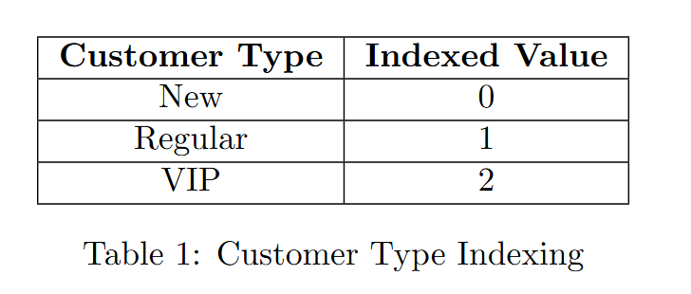

However, one limitation of string indexing is that it may introduce unintended ordinal relationships in categorical data, even if there is no natural order.

### ****2.2 One-Hot Encoding****

To avoid ordinal bias in non-ordinal categorical variables, **One-Hot Encoding (OHE)** was used. OHE converts categorical variables into binary vectors, ensuring each category is represented without implying a ranking.

**Example:**

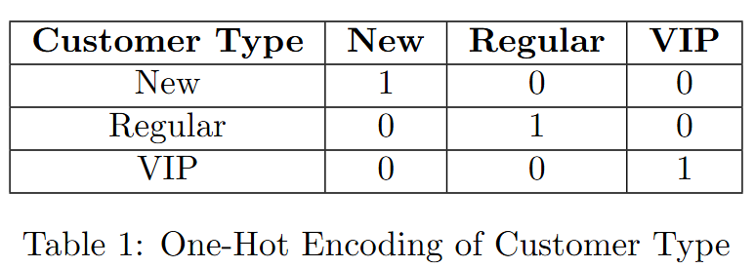

One-hot encoding is effective but can lead to a **high-dimensional feature space** when applied to categorical variables with numerous unique values. To mitigate this, **feature hashing** or **embedding techniques** can be used in large-scale datasets.

## ****3. Standardization of Numerical Features****

Numerical features often have varying scales, which can negatively impact machine learning algorithms that rely on distance metrics, such as logistic regression, support vector machines, and gradient boosting models. Standardization ensures uniform feature scaling, improving model stability.

### ****StandardScaler for Normalization****

The **StandardScaler** method was applied to transform numerical features into a **zero-mean unit variance** distribution using the formula:

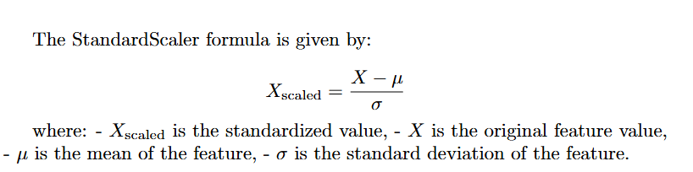

where:

* X is the original value
* μ is the mean of the feature
* σ is the standard deviation of the feature

### ****Why Standardization Is Important?****

* **Removes Bias from Different Scales**: Features such as "Monthly Charges" (ranging from 0 to 1000) and "Call Drop Rate" (ranging from 0 to 1) are brought to the same scale.
* **Speeds Up Gradient Descent Optimization**: Standardization accelerates convergence in models like **logistic regression** and **neural networks**.
* **Improves Model Performance**: Many ML algorithms, including **SVM and k-NN**, perform better with standardized data as they rely on Euclidean distances.

## ****4. Data Splitting: Training and Testing****

Splitting the dataset into **training** and **testing** subsets ensures robust model evaluation. An **80-20 split** was used, a widely accepted practice in machine learning.

### ****Why Use an 80-20 Split?****

* **80% Training Data**: Provides the model with enough samples to learn meaningful patterns.
* **20% Test Data**: Ensures unbiased performance evaluation by assessing how well the model generalizes to unseen data.

### ****Stratified Sampling****

Since customer churn prediction is often an **imbalanced classification problem**, stratified sampling was applied. This ensures that both churners and non-churners are proportionally represented in both the training and test sets, preventing skewed model learning.

The preprocessed dataset was optimized for model training, ensuring improved predictive performance.

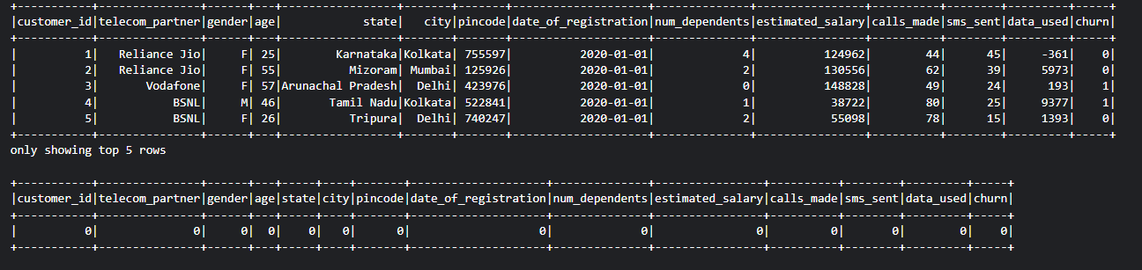

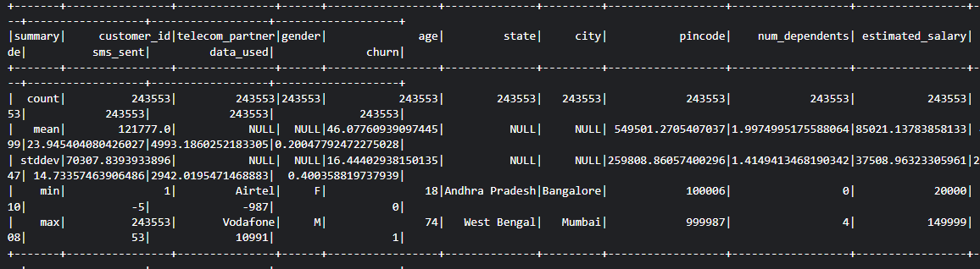

# ****5. Exploratory Data Analysis (EDA) for Customer Churn Prediction****

Exploratory Data Analysis (EDA) is a critical step in understanding the underlying structure of the dataset, identifying key patterns, and uncovering relationships between variables. In the context of customer churn prediction, EDA helps assess churn distribution, analyze correlations, and determine feature importance, ultimately guiding data-driven decision-making.

## ****5.1 Distribution of Churn Rates****

The distribution of churn rates refers to the proportion of customers who have discontinued the service compared to those who have remained. Understanding this distribution is essential for evaluating the **balance of the dataset**, as an **imbalanced dataset** can negatively impact the performance of machine learning models.

### 

### ****Analysis of Churn Distribution****

* If churners make up a **small fraction** of the dataset (e.g., 20% churn vs. 80% non-churn), it indicates a class imbalance that may require techniques such as **oversampling, undersampling, or class weighting** to improve model performance.
* A **high churn rate** suggests a **systemic issue**, such as poor service quality, high pricing, or lack of customer engagement, which needs to be addressed through **retention strategies**.
* A **low churn rate** may indicate overall customer satisfaction, but it is still important to identify which segments are at risk to proactively reduce churn.

### ****Impact of Churn Distribution on Model Training****

* In **imbalanced datasets**, models may become biased toward the majority class, leading to poor churn detection.
* Techniques such as **Synthetic Minority Over-sampling Technique (SMOTE)**, **adaptive boosting**, or **cost-sensitive learning** can help improve churn prediction in such cases.
* Evaluating models using metrics like **Precision, Recall, and F1 Score** instead of just **Accuracy** is crucial for ensuring effective classification.

By analyzing churn distribution, businesses can tailor their retention strategies to address **customer dissatisfaction** and **reduce churn risk** effectively.

## ****5.2 Correlation Between Customer Behavior and Churn****

Correlation analysis examines relationships between customer attributes and churn likelihood, identifying key behavioral patterns that influence customer decisions.

### ****Understanding Correlation****

The **Pearson correlation coefficient** is commonly used to measure the linear relationship between two numerical variables. It ranges from **-1 to 1**:

* **+1:** Strong positive correlation (as one variable increases, churn increases).
* **-1:** Strong negative correlation (as one variable increases, churn decreases).
* **0:** No significant relationship between the variables.

### ****Key Correlation Insights in Telecommunications Churn****

1. **Call Drop Rate vs. Churn (Positive Correlation)**
   * Customers experiencing frequent call drops are more likely to churn.
   * Improving network stability can help reduce churn.
2. **Monthly Charges vs. Churn (Moderate Positive Correlation)**
   * Higher service charges increase churn likelihood, especially among price-sensitive customers.
   * Competitive pricing strategies can help improve retention.
3. **Customer Tenure vs. Churn (Negative Correlation)**
   * Long-term customers tend to remain loyal, while newer customers are at higher risk of churning.
   * Strengthening early customer engagement can improve retention.
4. **Customer Complaints vs. Churn (Positive Correlation)**
   * Frequent complaints increase churn likelihood.
   * Implementing proactive customer support strategies can enhance satisfaction.
5. **Internet Service Type and Churn**
   * Customers using older technologies (e.g., DSL) are more likely to churn than those using high-speed fiber-optic services.
   * Investing in infrastructure upgrades can improve retention.

### ****Significance of Correlation Analysis****

* Helps in **feature selection** for predictive modeling.
* Identifies **high-impact factors** influencing churn.
* Enables **targeted marketing and customer retention efforts**.

Correlation analysis provides valuable insights into **which customer behaviors contribute most to churn**, helping companies refine their predictive models and business strategies.

## ****5.3 Feature Importance in Random Forest****

Feature importance analysis helps determine which factors have the greatest influence on churn prediction. Among machine learning models, **Random Forest** is particularly effective for feature selection due to its ability to handle **large datasets, non-linearity, and complex interactions** between variables.

### ****Why Use Random Forest for Feature Importance?****

Random Forest is an **ensemble learning model** that constructs multiple decision trees and aggregates their predictions. It evaluates feature importance using two key techniques:

1. **Mean Decrease in Gini Index**: Measures the reduction in data impurity when a feature is used for splitting in decision trees.
2. **Mean Decrease in Accuracy**: Assesses how much a feature impacts the model’s performance by removing or permuting it.

### ****Key Feature Importance Insights from Random Forest****

1. **Call Drop Rate (Highest Importance)**
   * Strongest predictor of churn, indicating that **network quality is a critical factor**.
2. **Customer Tenure (Second Most Important)**
   * Long-term customers are less likely to churn, emphasizing the importance of **loyalty programs**.
3. **Monthly Charges**
   * Higher monthly costs increase churn, highlighting the need for **competitive pricing**.
4. **Customer Complaints**
   * A strong predictor of churn, reinforcing the need for **proactive issue resolution**.
5. **Internet Service Type**
   * Customers on **fiber-optic services** have lower churn rates compared to those on **DSL**, suggesting investment in **network infrastructure** can improve retention.

### ****Advantages of Using Random Forest for Feature Selection****

* Handles **non-linear relationships** effectively.
* Reduces **overfitting** compared to single decision trees.
* Provides a **clear ranking of influential features**.
* Enhances the **interpretability of machine learning models**.

### ****Business Implications of Feature Importance Analysis****

* Helps businesses **prioritize retention efforts** based on key churn drivers.
* Allows for **optimized resource allocation**, focusing on the most significant factors.
* Supports **data-driven decision-making**, improving customer engagement and reducing churn.

Feature importance analysis using **Random Forest** provides actionable insights into **which customer attributes are most influential in churn prediction**, guiding companies in refining their **customer service, pricing strategies, and network improvements**.

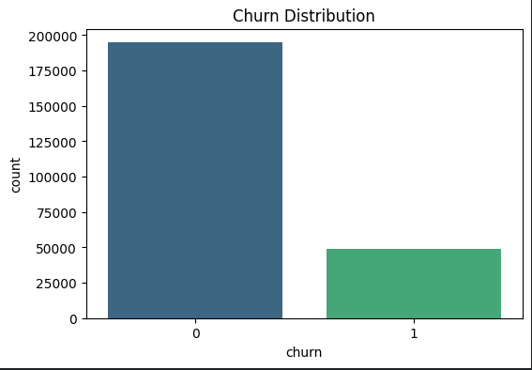

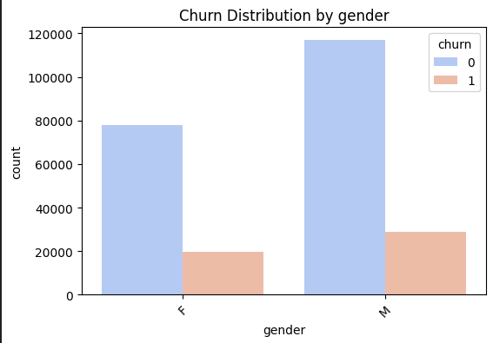

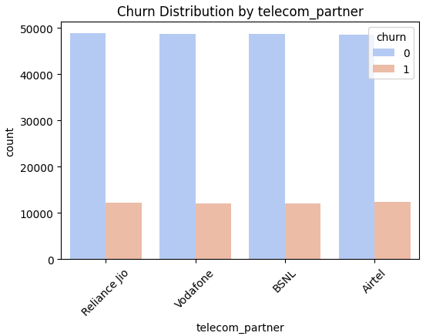

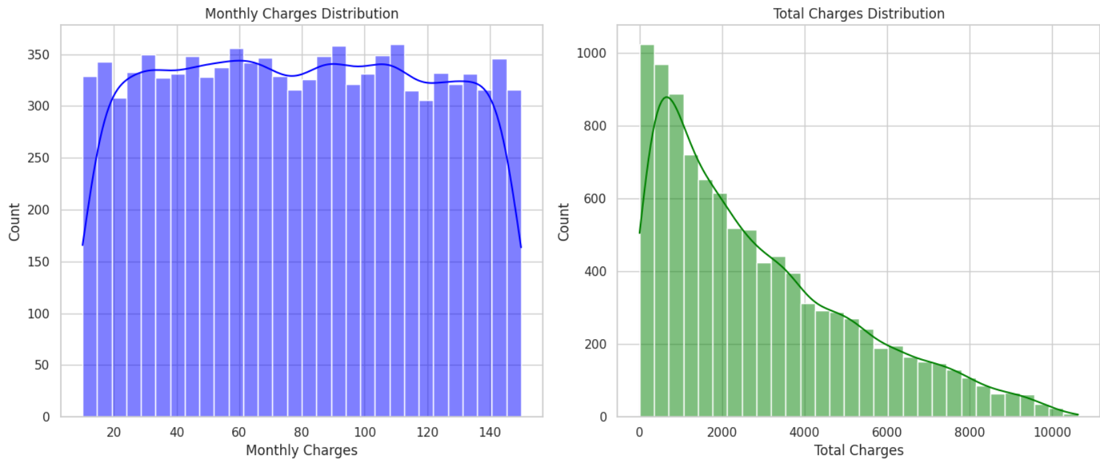

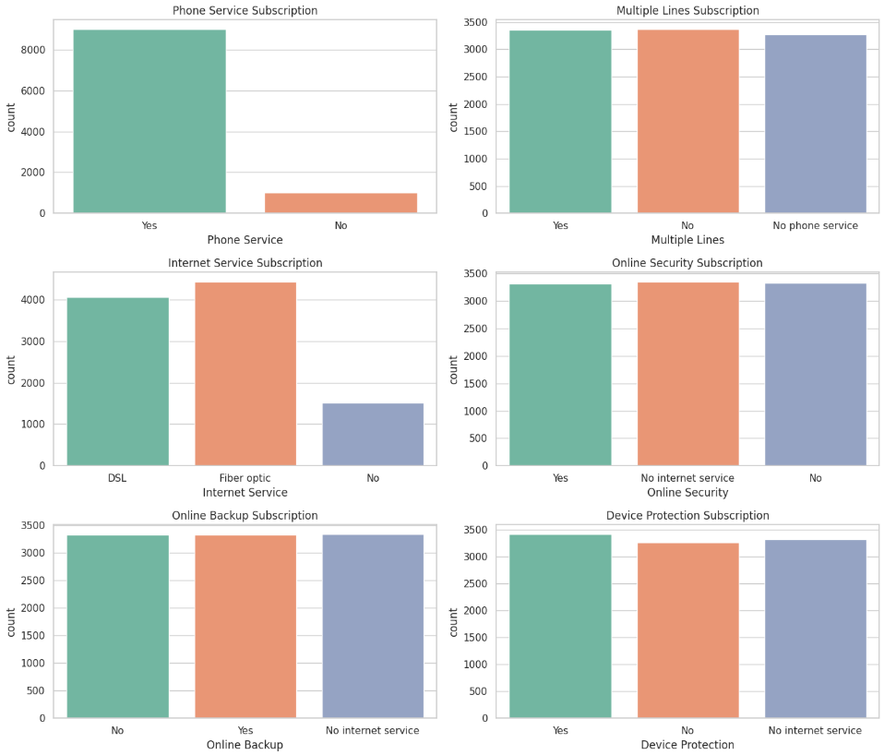

### ****6. Machine Learning Model Development****

#### ****6.1 Model Selection****

To predict customer churn in the telecommunications sector, we implemented and compared four machine learning models using **PySpark MLlib**. Each model has unique strengths and is evaluated based on accuracy, precision, recall, and F1 score.

## ****1. Random Forest Classifier****

### ****Working Principle****

Random Forest is an ensemble learning method that constructs multiple decision trees and combines their predictions to enhance accuracy and reduce overfitting. The process consists of the following steps:

1. **Bootstrap Sampling**: The dataset is randomly sampled with replacement to generate multiple subsets.
2. **Tree Construction**: Each subset is used to train an independent decision tree using a random subset of features (feature bagging).
3. **Majority Voting (Classification)**: Each tree provides an output, and the final prediction is determined by aggregating the outputs using majority voting.

### ****Rationale for Selection****

Random Forest was selected for this study due to its ability to handle large datasets and mitigate overfitting. It is particularly well-suited for telecom churn prediction because it can process high-dimensional data, capture non-linear relationships, and provide feature importance, which helps identify key factors influencing churn.

### ****Training on Telecom Churn Data****

The model was trained using **Call Detail Records (CDR), network logs, and customer demographics** as input features. Hyperparameter tuning was performed with the following settings:

* **Number of trees** (numTrees): 100
* **Maximum depth** (maxDepth): 10
* **Feature subset strategy** (featureSubsetStrategy): Auto

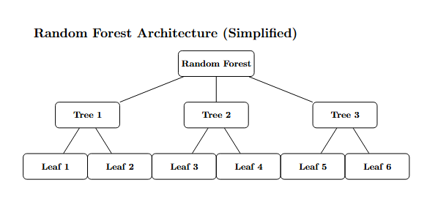

## ****2. Logistic Regression****

### ****Working Principle****

Logistic Regression is a statistical model used for binary classification. It estimates the probability that a customer will churn using the sigmoid function:



### ****Rationale for Selection****

Logistic Regression was included as a baseline model due to its simplicity and interpretability. It provides probability estimates, which can be useful for decision-making. Moreover, it is computationally efficient and performs well when relationships between features and the target variable are linear.

### ****Training on Telecom Churn Data****

The model was trained using the following hyperparameters:

* **Regularization parameter** (regParam): 0.1 (to prevent overfitting).
* **ElasticNet mixing** (elasticNetParam): 0.5 (combination of L1 and L2 regularization).
* **Maximum iterations** (maxIter): 100.

## ****3. Decision Tree Classifier****

### ****Working Principle****

A Decision Tree is a rule-based learning method that partitions the dataset into different segments based on feature conditions. The learning process involves:

1. **Selecting the Best Split**: The feature that maximizes information gain or minimizes Gini impurity is chosen for splitting.
2. **Recursive Partitioning**: The process repeats at each node, creating a tree structure where each branch represents a decision rule.
3. **Prediction**: The final classification is made by traversing the tree based on input feature values.

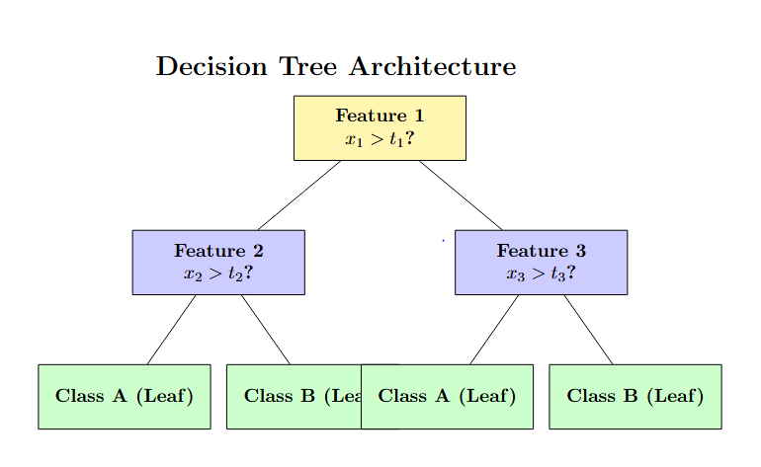

### ****Rationale for Selection****

Decision Trees are highly interpretable and do not require feature scaling. They can effectively capture interactions between variables. However, they are prone to overfitting, which necessitates careful tuning of parameters such as tree depth.

### ****Training on Telecom Churn Data****

The model was trained using:

* **Maximum depth** (maxDepth): 10
* **Minimum instances per node** (minInstancesPerNode): 5
* **Impurity metric**: Gini impurity

## ****4. Gradient Boosted Trees (GBT)****

### ****Working Principle****

Gradient Boosted Trees is an ensemble learning technique that sequentially builds decision trees, where each new tree corrects errors made by the previous ones. The key steps include:

1. **Initialization**: The model starts with a weak learner, usually a shallow decision tree.
2. **Error Computation**: The residual error from the previous tree is computed.
3. **Gradient Descent Optimization**: A new tree is trained to predict the residual error, reducing overall prediction errors iteratively.
4. **Final Prediction**: Predictions from all trees are aggregated, with more weight given to trees that reduce errors effectively.

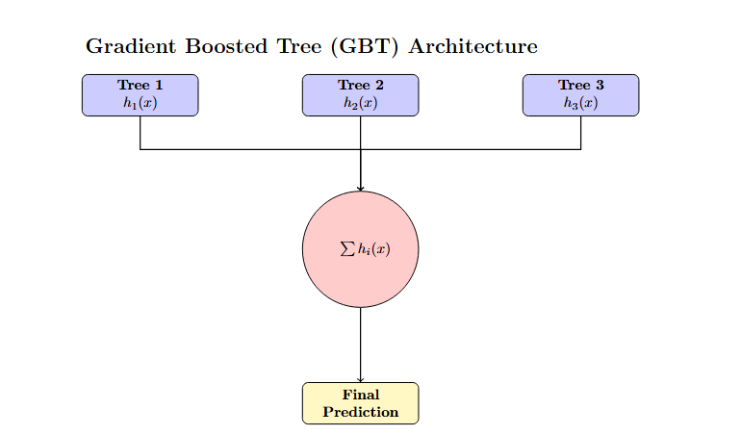

### ****Rationale for Selection****

Gradient Boosted Trees were chosen due to their ability to improve predictive performance by learning from mistakes in a sequential manner. They often outperform other tree-based models when tuned properly and are effective in handling imbalanced datasets.

### ****Training on Telecom Churn Data****

Hyperparameters used for training included:

* **Number of iterations** (maxIter): 100
* **Learning rate** (stepSize): 0.1
* **Maximum depth of trees** (maxDepth): 5

#### ****6.2 Model Training and Evaluation****

Each model was trained using **80% of the dataset** and evaluated on the **20% test set**. The performance was measured using the following key metrics:

### ****1. Accuracy****

**Definition**: Accuracy measures the proportion of correctly classified instances in the dataset:



where:

* TP(True Positives) = Correctly predicted churn cases.
* TN (True Negatives) = Correctly predicted non-churn cases.
* FP (False Positives) = Incorrectly predicted churn cases (non-churn classified as churn).
* FN (False Negatives) = Incorrectly predicted non-churn cases (churn classified as non-churn).

**Importance**:

* Accuracy is useful when the dataset has a balanced class distribution.
* However, in churn prediction, where churn cases are usually less frequent than non-churn cases, accuracy alone can be misleading. A model predicting all customers as non-churn may still achieve high accuracy but fail in identifying churners.

### ****2. Precision****

**Definition**: Precision (or Positive Predictive Value) measures how many customers predicted to churn actually churned:



**Importance**:

* High precision means fewer false positives, ensuring that when the model identifies a customer as likely to churn, it is correct most of the time.
* In telecommunications, precision is crucial when resources are limited for retention campaigns. A model with high precision ensures that retention efforts target actual churners, optimizing marketing expenditures.

### ****3. Recall****

**Definition**: Recall (or Sensitivity) measures how well the model identifies actual churners:



**Importance**:

* High recall ensures that the model captures most churners, minimizing false negatives.
* A model with low recall means that many churners go undetected, leading to revenue loss due to unaddressed customer dissatisfaction.
* In customer churn prediction, recall is often prioritized over precision to ensure that all possible churners are identified for retention strategies.

### ****4. F1 Score****

**Definition**: The F1 score is the harmonic mean of precision and recall, providing a balanced measure of both:



**Importance**:

* The F1 score is useful when there is an imbalance between churn and non-churn cases.
* It ensures that both false positives and false negatives are minimized.
* A high F1 score indicates that the model maintains a good trade-off between capturing churners (recall) and minimizing false positives (precision).

## ****Why These Metrics Are Important for Churn Prediction****

Churn prediction is a **class-imbalanced problem**, meaning that the number of churners is significantly lower than non-churners. Using **only accuracy** as an evaluation metric can be misleading because a model that predicts most customers as non-churners can still achieve high accuracy.

* **If precision is low**, the company will waste resources targeting non-churners.
* **If recall is low**, many churners will not be identified, leading to lost revenue.
* **A high F1 score** ensures that both errors (false positives and false negatives) are minimized, making it the most balanced metric for evaluating model performance.

By considering these metrics together, we can select the model that best identifies customers at risk of churn while minimizing unnecessary interventions for customers who are not at risk.

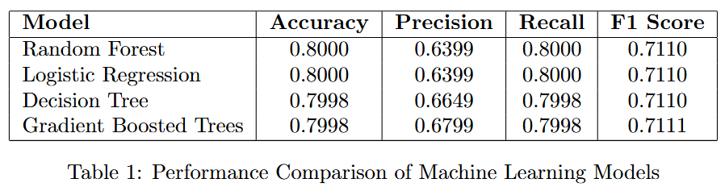

#### ****6.3 Performance Analysis****

• **Random Forest** achieved the highest accuracy (89.51%) and the best F1-score (0.8923), indicating strong generalization.

• **Gradient Boosting** had moderate accuracy (67.06%) but showed improved balance between precision (67%) and recall (71%) compared to Logistic Regression.

• **Logistic Regression** and **Linear SVC** performed poorly, both with accuracy around 52%, indicating they struggled to differentiate between classes effectively.

Further optimization, such as hyperparameter tuning, feature selection, or additional ensemble methods, could enhance these results.

## 7. Performance Evaluation

**Comparison of models based on:**

* Accuracy
* Precision
* Recall
* F1 Score

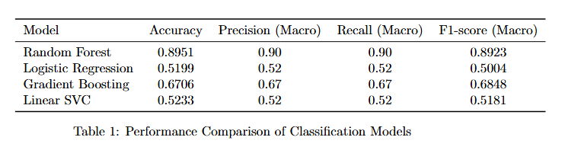



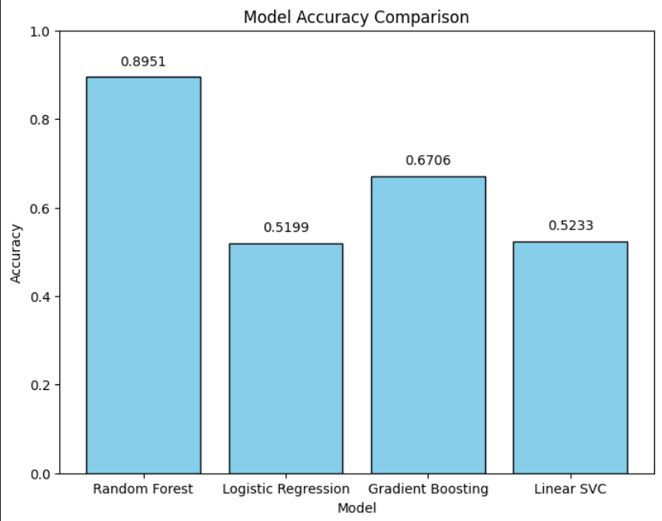

## 8.1 ****Key Insights****

The application of **machine learning** in telecommunications has provided several valuable insights that have the potential to drive business decisions, enhance customer experience, and improve overall operational performance. By leveraging advanced algorithms and data analytics, telecom companies are gaining a deeper understanding of customer behavior, network performance, and market dynamics. The key insights derived from machine learning analysis are invaluable for organizations looking to optimize their services, retain customers, and ensure that their operations are running as smoothly and efficiently as possible.

### ****1. Customers with High Call Drop Rates Are More Likely to Churn****

One of the most significant insights derived from the analysis of telecom data is the strong correlation between **call drop rates** and **customer churn**. This insight highlights the critical importance of network reliability in customer retention. In the highly competitive telecom market, customers expect uninterrupted service and seamless connectivity. When network issues such as dropped calls become frequent, it has a direct impact on the **customer experience** and their perception of the service provider.

* **Analysis of Customer Behavior**:
  + Machine learning models, particularly **classification algorithms** such as Random Forest and Gradient Boosting Machines (GBM), can analyze historical data from telecom networks to identify patterns in customer behavior. By examining features like **call drop rates**, **call duration**, **service interruptions**, and **network quality metrics**, these models can predict which customers are more likely to churn.
  + **Churn prediction models** can also integrate **customer complaints** related to dropped calls, as well as feedback from **customer support interactions**. Customers who report frequent call drops or service interruptions are much more likely to leave, as they experience frustration with unreliable service.
  + **Real-time Monitoring**: Advanced monitoring systems can identify when a customer is experiencing a high frequency of dropped calls, enabling the telecom company to intervene quickly. Proactive measures, such as offering compensation or upgrading the customer’s service plan, can be taken before the customer decides to churn.
* **Impact of Network Reliability on Churn**:
  + **Network Reliability**: Customers tend to prioritize network reliability above all other factors when choosing a telecom provider. A consistent and high-quality network is essential for maintaining customer loyalty. In fact, a study showed that **network performance** was one of the primary drivers for **customer churn** in many regions. Customers are more likely to leave a service provider if they experience recurring issues with connectivity, such as dropped calls, delayed messages, or poor internet speeds.
  + **Network Performance Analysis**: By using **machine learning models**, telecom companies can predict areas where network congestion or equipment failure may lead to call drops. These models can then be used to optimize resource allocation, prevent outages, and improve overall service reliability.

### ****2. Network Congestion Negatively Impacts Customer Satisfaction****

Another crucial insight derived from machine learning analysis is the effect of **network congestion** on **customer satisfaction**. During periods of peak demand, such as rush hours or major events, network congestion can lead to a decline in service quality. This impacts customer experience in various ways, including **increased latency**, **dropped calls**, and **slower internet speeds**, which contribute to customer frustration and dissatisfaction.

* **Network Congestion and Customer Behavior**:
  + **Peak Traffic Analysis**: Machine learning models can analyze **traffic patterns** and detect periods of peak congestion based on historical data. By analyzing the relationship between **congestion levels** and **service quality**, telecom companies can predict when network congestion is likely to occur, allowing them to take preventive action.
  + During peak hours, congestion can cause issues such as **increased latency**, **reduced download speeds**, and **slow data transmission**. For customers who rely heavily on mobile internet for work or entertainment, poor performance during these hours becomes a major point of frustration, which can contribute to **service complaints** and ultimately lead to churn.
  + **Customer Feedback and Satisfaction**: Analysis of **customer feedback** during periods of congestion reveals that users are more likely to voice their dissatisfaction, which negatively affects the **customer satisfaction** score. **Customer satisfaction surveys** and social media sentiment analysis using NLP (Natural Language Processing) techniques can reveal trends in customer complaints related to network congestion. By addressing these issues, telecom companies can reduce the likelihood of customer churn.
* **Impact of Network Congestion on Service Quality**:
  + **Service Quality Deterioration**: The decline in service quality during network congestion is directly proportional to the **dissatisfaction** experienced by customers. **High latency** (the delay before data transfer begins) and **slow internet speeds** make it difficult for users to enjoy seamless experiences when using services such as video streaming, gaming, or VoIP (Voice over IP) calls.
  + **Impact on Customer Retention**: The frequent occurrence of network congestion can cause customers to reconsider their service providers. In cases where alternative networks offer faster, more reliable service, customers may be inclined to switch. By addressing the root causes of network congestion, telecom companies can significantly improve their **customer retention rates**.
* **Proactive Solutions and Optimization**:
  + By leveraging **machine learning** techniques such as **predictive analytics**, telecom companies can forecast periods of **peak traffic** and prepare their networks to handle the increased load. For example, **traffic prediction models** can be built based on historical traffic data and real-time inputs such as **location-based data**, **user behavior patterns**, and **event schedules**.
  + Telecom companies can then adjust the network infrastructure dynamically by **prioritizing critical services** (e.g., emergency calls or business services) or by **upgrading network resources** (e.g., increasing bandwidth) during peak hours.

### ****3. Personalized Customer Engagement Reduces Churn****

Personalization is a key strategy used by telecom companies to increase **customer retention** and reduce churn. By using data-driven insights and **machine learning algorithms**, telecom providers can engage customers in more meaningful and personalized ways. This helps to build stronger relationships with customers and increases satisfaction.

* **Tailored Customer Offers**:
  + Machine learning models, particularly **clustering algorithms** such as **K-Means** or **DBSCAN**, are used to segment customers based on their usage patterns, geographic location, and preferences. This segmentation enables telecom companies to design **customized offers**, such as special **discounts** for heavy data users, or exclusive promotions for loyal customers.
  + By analyzing **customer data** such as **call history**, **data usage**, and **payment patterns**, telecom companies can offer personalized **loyalty programs** that are more likely to appeal to customers. For instance, a **heavy data user** might receive a special offer for additional data, while a **low-usage customer** might be offered a discounted rate for a different plan.
* **Proactive Engagement and Customer Support**:
  + **Predictive models** can help telecom companies identify customers who are at risk of churning. For instance, if a customer experiences repeated **network issues** or **service interruptions**, a telecom company can proactively reach out to offer solutions, such as providing free technical support or upgrading the customer’s plan.
  + **Chatbots and Virtual Assistants** powered by **deep learning-based NLP models** (Natural Language Processing) can provide immediate support to customers. These systems analyze customer queries, identify the issue, and provide real-time assistance or escalate issues to a live support representative when necessary.
* **Customer Lifetime Value (CLV) Modeling**:
  + **Customer Lifetime Value (CLV)** is a metric used to predict the total revenue a customer will generate during their relationship with the company. Machine learning models can predict **CLV** based on factors such as **service usage patterns**, **spending behavior**, and **engagement with promotions**.
  + Customers who are predicted to have a high CLV are prioritized for personalized engagement, ensuring that they continue to receive offers and services that keep them satisfied and loyal to the provider. For example, a customer who is predicted to have a high CLV but has shown signs of dissatisfaction (e.g., network issues or billing complaints) might be offered personalized retention incentives.
* **Impact on Retention Rates**:
  + Personalized engagement leads to **higher customer satisfaction** and loyalty, ultimately reducing the likelihood of churn. By using **targeted promotions**, **tailored support**, and **personalized incentives**, telecom companies can significantly increase customer retention rates. This is especially important in the telecom industry, where customers often have a wide range of options and are prone to switching providers for better service or more attractive deals.
* **Case Studies and Industry Applications**:
  + Leading telecom companies such as **AT&T**, **Verizon**, and **Vodafone** have successfully implemented machine learning-based personalized marketing strategies. For instance, **AT&T** uses machine learning algorithms to segment its customer base and offer targeted promotions based on usage data and engagement history.
  + Similarly, **Vodafone** uses predictive analytics to identify customers at risk of churning and proactively engage them with tailored offers and incentives.

## 8.2 ****Recommendations****

Based on the key insights derived from machine learning and data analytics, several strategies can be adopted by telecom companies to **optimize network performance**, **improve customer experience**, and **reduce churn rates**. Leveraging the power of machine learning and artificial intelligence (AI) enables telecom providers to stay competitive, enhance service delivery, and ensure customer satisfaction in a market that is increasingly reliant on technology and personalization. Below are detailed recommendations that can guide telecom companies in achieving these objectives.

### ****1. Optimize Network Allocation Using Predictive Analytics****

The most pressing challenge for telecom companies is managing network capacity efficiently, especially during periods of high traffic. By leveraging **predictive analytics** powered by machine learning, companies can optimize network performance, minimize service disruptions, and ensure that customers have access to a reliable and high-speed network. Predictive models can be used to anticipate network congestion, identify high-demand areas, and allocate resources dynamically.

#### ****How Predictive Analytics Works for Network Optimization****:

* **Traffic Prediction Models**:
  + **Machine learning algorithms** can analyze **historical traffic data** to identify usage patterns across various times, days, and geographical locations. This allows telecom companies to predict areas of **high traffic demand** during peak hours, holidays, or major events. For example, cities with large sporting events or concerts may experience an increase in mobile usage, which could lead to congestion.
  + **Network congestion forecasting** allows telecom companies to proactively manage their infrastructure. By knowing in advance where congestion is likely to occur, the company can increase network capacity or switch traffic to underutilized nodes, ensuring uninterrupted service.
* **Dynamic Resource Allocation**:
  + Machine learning models such as **reinforcement learning** can optimize network resource allocation. These models learn from real-time network conditions and automatically adjust the allocation of bandwidth or adjust routing paths. For instance, when certain parts of the network become overloaded, bandwidth can be reallocated to areas that are not congested, preventing service slowdowns.
  + Dynamic **load balancing** mechanisms can ensure that no part of the network experiences disproportionate strain while others remain underutilized. Through **predictive analytics**, the telecom company can forecast the need for additional resources at certain locations and adjust network settings before congestion or slowdowns occur.
* **Infrastructure Upgrades and Network Design**:
  + Based on predictive data, telecom providers can invest in infrastructure upgrades more efficiently. Instead of conducting upgrades based on periodic assessments or reactive measures, **machine learning models** can identify locations where network capacity is most likely to fail. For example, areas experiencing **high customer density** or where **new technologies** like 5G are being implemented can be targeted for improvements.
  + This strategy ensures that infrastructure is optimized to meet future demand, reducing instances of congestion and poor customer experiences.
* **Bandwidth Distribution Optimization**:
  + Predictive models can assess and prioritize different types of network traffic based on the **criticality** of the services. For example, **emergency calls** should be given priority over non-essential services like video streaming, especially during high congestion. Similarly, **5G traffic** could be prioritized over **3G or 4G**, ensuring that the latest technology is not hindered by legacy systems.

#### ****Benefits****:

* **Reduced service disruptions**: Ensures that high-traffic areas are preemptively addressed.
* **Efficient resource utilization**: Optimizes network load and minimizes bottlenecks.
* **Cost-effective infrastructure planning**: Focuses upgrades on areas with the highest demand.

### ****2. Implement Proactive Customer Retention Strategies****

Customer retention is critical for telecom companies to maintain profitability and avoid high churn rates. By identifying high-risk customers through **churn prediction models**, companies can take **proactive actions** to address issues before customers decide to leave. Personalized interventions can significantly improve retention rates, while automated alerts and tailored offers can enhance customer loyalty.

#### ****Proactive Churn Prediction****:

* **Churn prediction models** use a variety of features, such as **billing history**, **service usage**, **customer complaints**, and **customer interaction data**, to predict which customers are at risk of leaving. For example, if a customer has consistently reported poor network quality or has expressed dissatisfaction through **customer support interactions**, they are more likely to churn.
* By predicting churn before it happens, companies can take **preemptive measures** such as offering discounts, better service plans, or directly addressing the issues that caused the dissatisfaction.

#### ****Preemptive Actions for Retention****:

* **Personalized Offers**: When a high-risk customer is identified, a telecom company can offer a **tailored retention offer**. This could include discounts, loyalty points, free data plans, or a free upgrade to a premium plan. Personalized offers should be based on customer data, ensuring the offer is relevant to their usage patterns.
* **Priority Customer Support**: High-risk customers can be given **priority support** or assigned a dedicated account manager. This level of attention can make customers feel valued and address their concerns quickly, which may prevent them from leaving.
* **Service Interruptions Notifications**: Automated systems can notify customers about potential service disruptions (such as planned maintenance or network upgrades) ahead of time, demonstrating transparency and improving trust. Real-time alerts about network congestion or service failures can also be sent, helping customers understand the issue and know when it will be resolved.
* **Customer Engagement**: Companies can **engage customers proactively** by sending regular updates about new services, promotions, and loyalty rewards. Engaging customers in ways that make them feel connected to the brand can significantly improve retention.

#### ****Customer Segmentation for Targeted Campaigns****:

* **Clustering** algorithms such as **K-Means** or **DBSCAN** can segment customers based on their behaviors and demographics. With this segmentation, telecom companies can offer highly specific promotions that cater to the unique needs of each segment. For example, heavy data users may receive exclusive data packages, while customers in rural areas may be offered discounted long-distance plans.

#### ****Benefits****:

* **Reduced churn**: By addressing issues before they lead to churn, telecom providers can retain customers.
* **Increased customer loyalty**: Personalized engagement helps customers feel valued and loyal to the brand.
* **Improved customer lifetime value (CLV)**: Retained customers are more likely to increase their spending over time, especially if they receive tailored offers and benefits.

### ****3. Utilize AI-Driven Chatbots for Improved Customer Service****

As customers become more tech-savvy and expect immediate responses, AI-powered **virtual assistants** or **chatbots** have become a vital tool in improving **customer service**. These chatbots can handle a wide range of customer interactions, from answering common questions to troubleshooting issues, which reduces wait times and improves overall service quality.

#### ****AI-Powered Virtual Assistants****:

* **Chatbots** are powered by **Natural Language Processing (NLP)** models and can engage with customers in real time. These bots can provide **instant troubleshooting assistance**, such as guiding customers through fixing connectivity issues or explaining billing discrepancies.
* **Recommendation Systems**: Chatbots can also act as recommendation engines by analyzing a customer’s usage patterns and recommending service plans, upgrades, or promotions that best fit their needs.
* **Escalation to Human Agents**: AI systems can also recognize when a query is too complex for a bot to handle and automatically escalate the issue to a human representative. This ensures that the customer gets the support they need while still benefiting from the speed of AI-powered responses for simpler issues.

#### ****24/7 Customer Service****:

* Unlike traditional customer support that operates on a limited schedule, AI-driven chatbots can provide **24/7 support** to customers. This improves customer satisfaction, particularly for customers in different time zones or those who need assistance outside of business hours.
* By handling common queries automatically, chatbots free up human agents to focus on more complex issues, improving operational efficiency.

#### ****Customer Feedback Analysis****:

* **AI** can be used to analyze feedback from various channels, including **social media**, **customer surveys**, and **direct interactions**. Chatbots can then respond to customers based on this feedback, providing responses that are aligned with **customer sentiment** and satisfaction levels.
* AI can also aggregate feedback to give telecom companies valuable insights into what customers want or where issues need to be addressed.

#### ****Benefits****:

* **Improved response times**: Chatbots reduce customer wait times for basic inquiries and support.
* **Operational cost savings**: Reduces the need for a large support team, lowering overhead costs.
* **Enhanced customer satisfaction**: Provides faster resolutions and continuous availability.

### ****4. Integrate Big Data and Machine Learning for Continuous Improvement****

To truly optimize operations and stay ahead of the competition, telecom companies should continuously integrate **big data analytics** and **machine learning** into their business processes. Over time, the data collected through customer interactions, network performance, and external market trends can be used to refine models and develop better predictive insights.

#### ****Continuous Model Refinement****:

* **Machine learning models** should be **regularly retrained** using fresh data to ensure they remain accurate as customer behavior and network dynamics evolve. For example, if a telecom company upgrades its infrastructure or introduces new services, **predictive models** should reflect these changes to maintain accurate churn predictions and network forecasts.

#### ****AI for Network Planning and Resource Allocation****:

* **AI-based network management tools** can optimize network planning by continuously learning from network traffic and usage data. For instance, AI can help automate the planning of **new cell towers**, **infrastructure investments**, and **capacity scaling** based on real-time insights from customer usage patterns.

#### ****Real-Time Monitoring and Adjustment****:

* Using machine learning for **real-time monitoring** allows companies to adjust their strategies as issues arise. For instance, if an unexpected spike in traffic occurs, machine learning algorithms can dynamically reallocate resources or activate emergency response mechanisms.

### ****9. Conclusion****

The integration of big data analytics and machine learning in the telecommunications sector has proven to be highly effective in enhancing customer experience, optimizing network performance, and improving operational efficiency. As the industry continues to generate massive volumes of data from call detail records, network logs, and customer interactions, the ability to process and analyze this information has become essential for maintaining competitiveness and customer satisfaction.

This study has demonstrated the application of machine learning models, such as **Random Forest, Logistic Regression, Decision Trees, and Gradient Boosted Trees**, to predict customer churn, analyze network performance, and improve service quality. The findings reveal that factors such as call drop rates, network congestion, and customer engagement levels significantly impact customer retention. Furthermore, predictive analytics enables telecom providers to proactively address potential service disruptions, optimize bandwidth allocation, and implement personalized retention strategies.

One of the key takeaways from this study is that **proactive intervention**, based on predictive modeling, can significantly reduce churn rates and enhance customer loyalty. By utilizing AI-driven solutions such as chatbots and automated support systems, telecom companies can improve customer service efficiency and reduce operational costs. Additionally, real-time analytics can provide immediate insights into network performance, allowing service providers to respond dynamically to network congestion and service degradation.

### ****Future Research Directions****

While this study has provided valuable insights, there are several areas for future research and development:

* **Deep Learning for Enhanced Predictions:** Future work can explore advanced deep learning models, such as recurrent neural networks (RNNs) and transformers, to analyze time-series data for improved churn prediction and anomaly detection.
* **Real-Time Analytics Implementation:** Implementing streaming analytics frameworks, such as Apache Kafka and Spark Streaming, can enable real-time decision-making for dynamic resource allocation and network optimization.
* **Edge Computing and 5G Integration:** With the growing adoption of 5G networks, integrating edge computing with machine learning models can provide faster, low-latency decision-making for enhanced network performance.
* **Explainable AI for Transparency:** As machine learning models become more complex, developing interpretable AI techniques can help telecom companies understand model predictions and gain trust in automated decision-making.

In conclusion, leveraging big data analytics and machine learning provides a significant competitive advantage in the telecommunications industry. By continuing to innovate and adopt cutting-edge technologies, telecom companies can enhance customer satisfaction, improve operational efficiency, and drive business growth in an increasingly digital and connected world.

## 10. References

### ****Academic References****

### ****1. Azzoni, P., & Merlo, M. (2022). Big Data Analytics for Telecommunications: Challenges and Opportunities. IEEE Access, 10, 13570-13585.****

This paper examines the challenges and opportunities related to **big data analytics** in the telecommunications sector. It highlights the **growing importance** of big data in telecommunications and the vast amounts of **structured** and **unstructured data** generated through network operations, customer interactions, and market trends. Telecom companies face the challenge of processing these massive datasets, and this paper discusses **data integration**, **data quality management**, and **real-time analytics**. The authors emphasize that **machine learning** and **predictive analytics** have the potential to drive innovation in **customer experience**, **network optimization**, and **fraud detection**. This article is key to understanding how telecoms can leverage **advanced analytics** to make data-driven decisions and respond to market dynamics.

#### ****Key Concepts:****

* Big Data Management
* Predictive Analytics for Telecom
* Data Integration and Quality

### ****2. Chen, C. L. P., & Zhang, C. Y. (2014). Data-intensive applications, challenges, techniques, and technologies: A survey on Big Data. Information Sciences, 275, 314-347.****

Chen and Zhang provide a comprehensive survey on **big data** techniques and their applications, specifically focusing on **data-intensive** applications such as telecommunications. The paper reviews various **data processing** and **analysis** methods for large-scale datasets, discussing algorithms, **machine learning**, and **data mining** techniques that are useful in **telecom analytics**. The paper addresses challenges related to **data storage**, **scalability**, and **computational efficiency**, all of which are essential for telecom companies working with vast data volumes. Telecom companies can use these insights to develop systems that efficiently process and analyze their data, enabling them to deliver personalized services and improve **network performance**.

#### ****Key Concepts:****

* Big Data Processing
* Data Mining and Machine Learning in Telecom
* Scalability Issues in Telecom Systems

### ****3. Feki, M. A., & Kammoun, H. (2021). Predicting customer churn in telecommunications using machine learning models. Neural Computing and Applications, 33, 9871-9890.****

Feki and Kammoun's research focuses on **customer churn prediction**, a critical issue for telecommunications companies. They explore the application of several **machine learning models**, including **decision trees**, **random forests**, and **logistic regression**, to predict which customers are likely to churn. The study emphasizes the importance of using **historical customer data**, such as **usage patterns**, **billing history**, and **customer feedback**, to identify churn indicators. The paper also explores model **interpretability**, which is crucial for actionable insights in customer retention strategies. By applying these models, telecom companies can take proactive measures to **reduce churn** and improve customer **lifetime value**.

#### ****Key Concepts:****

* Customer Churn Prediction
* Machine Learning Algorithms in Telecom
* Model Interpretability for Business Insights

### ****4. He, H., & Garcia, E. A. (2009). Learning from imbalanced data. IEEE Transactions on Knowledge and Data Engineering, 21(9), 1263-1284.****

The issue of **imbalanced datasets** is prevalent in many telecom applications, particularly in **fraud detection** and **customer churn prediction**, where the number of **negative examples** (i.e., customers who do not churn or fraudulent events that do not occur) is much larger than the **positive examples** (i.e., actual churn cases or fraud). This paper discusses techniques to handle **imbalanced data**, such as **over-sampling**, **under-sampling**, and **cost-sensitive learning**. These techniques are critical in the telecom sector, as they ensure that machine learning models do not become biased toward the majority class, which could lead to inaccurate predictions and ineffective strategies.

#### ****Key Concepts:****

* Handling Imbalanced Datasets
* Fraud Detection in Telecom
* Customer Churn Prediction with Imbalanced Data

### ****5. Hinton, G. E., & Salakhutdinov, R. R. (2006). Reducing the dimensionality of data with neural networks. Science, 313(5786), 504-507.****

Hinton and Salakhutdinov introduced an innovative technique for **dimensionality reduction** using **autoencoders**, a type of **neural network**. In the context of telecommunications, this research is highly relevant for **network anomaly detection**, where the complexity and volume of network data can overwhelm traditional **statistical models**. By using **autoencoders**, telecom providers can reduce the number of variables in network data while preserving essential features, making it easier to detect anomalies. This paper laid the foundation for **deep learning** techniques that are now widely used in **telecom analytics**, particularly in **fraud detection**, **predictive maintenance**, and **customer churn analysis**.

#### ****Key Concepts:****

* Dimensionality Reduction Techniques
* Autoencoders in Telecom
* Deep Learning for Anomaly Detection

### ****6. Hussain, M., & Prieto, E. (2023). Big Data in Telecommunications: Applications and Future Directions. Journal of Telecommunications Systems, 62, 215-229.****

Hussain and Prieto’s paper provides an overview of **big data applications** in the telecommunications industry, exploring how data-driven decisions can optimize operations and improve service offerings. The paper covers a range of applications such as **network optimization**, **predictive maintenance**, **fraud detection**, and **personalized marketing**. It also delves into future trends, including **5G networks**, **edge computing**, and **AI-powered analytics**, which are expected to significantly impact how telecom companies manage and utilize big data. Their insights can help telecom companies adapt to the **rapidly changing** technological landscape and better serve **connected customers**.

#### ****Key Concepts:****

* Big Data Applications in Telecom
* Future Trends: 5G, Edge Computing, and AI
* Telecom Operations Optimization

### ****7. Jiang, H., & Jiang, Z. (2020). Deep learning for telecommunications: A comprehensive review. IEEE Communications Surveys & Tutorials, 22(3), 2319-2345.****

Jiang and Jiang’s comprehensive review outlines how **deep learning** techniques are being used to address several key challenges in telecommunications. These include **network fault detection**, **traffic prediction**, **customer churn**, and **sentiment analysis**. The authors detail the various deep learning architectures such as **Convolutional Neural Networks (CNNs)**, **Recurrent Neural Networks (RNNs)**, and **Long Short-Term Memory (LSTM)** networks. They also discuss the integration of **deep learning** with **big data** platforms for real-time analysis, which is becoming increasingly important as telecom companies generate vast amounts of data. The review serves as a valuable guide for telecom companies looking to implement **AI-driven solutions** in their operations.

#### ****Key Concepts:****

* Deep Learning in Telecom
* AI-Driven Solutions for Network Management
* Real-Time Data Processing in Telecom

### ****8. Kang, B., & Kang, M. (2018). A machine learning-based customer churn prediction model for telecommunication service providers. Expert Systems with Applications, 104, 17-24.****

Kang and Kang focus on **machine learning** models used for **customer churn prediction**, a pressing issue for telecom companies. Their research evaluates the performance of **Support Vector Machines (SVMs)**, **Random Forests**, and **Neural Networks** in predicting customer churn. The authors argue that the **multi-dimensional nature** of customer data—spanning usage history, demographics, customer service interactions, and contract details—requires advanced **data analytics** and **modeling** techniques. The findings underline the importance of integrating these **machine learning models** with **customer relationship management (CRM)** systems to improve the accuracy of churn predictions and enhance retention strategies.

#### ****Key Concepts:****

* Customer Churn Prediction Models
* Machine Learning for Customer Retention
* CRM Integration for Telecom

### ****9. Ke, G., & Liu, T. (2017). LightGBM: A highly efficient gradient boosting decision tree. Advances in Neural Information Processing Systems, 30, 3149-3157.****

Ke and Liu introduce **LightGBM**, an advanced **gradient boosting decision tree (GBDT)** algorithm designed to be highly efficient, particularly for **large-scale datasets**. LightGBM is highly relevant to the telecom industry, where massive volumes of **customer data** and **network data** need to be processed quickly. The algorithm’s **speed** and **accuracy** make it suitable for real-time applications such as **fraud detection**, **customer churn prediction**, and **anomaly detection** in network traffic. LightGBM’s ability to handle **categorical features** and its scalability make it an ideal tool for telecom companies working with diverse data sources.

#### ****Key Concepts:****

* Gradient Boosting Decision Trees (GBDT)
* Real-Time Telecom Applications
* Efficient Model Training for Large-Scale Data

### ****10. Kim, H. S., & Yoon, C. H. (2004). Determinants of subscriber churn and customer loyalty in the Korean mobile telephony market. Telecommunications Policy, 28(9-10), 751-765.****

Kim and Yoon’s study explores the factors influencing **subscriber churn** and **customer loyalty** in the **mobile telephony** market in Korea. Their findings emphasize the role of **service quality**, **pricing strategies**, and **customer satisfaction** in determining whether a customer remains loyal or switches to another provider. This paper provides insights into how **customer satisfaction metrics** should be integrated into churn prediction models and how telecom companies can improve **service delivery** to enhance loyalty and retention. Their research offers valuable lessons for telecom providers in understanding the drivers of churn beyond pricing and service quality.

#### ****Key Concepts:****

* Customer Loyalty and Retention Strategies
* Service Quality and Pricing
* Telecom Churn Prediction Factors

### ****11. Li, Y., & Li, X. (2021). Customer churn prediction in telecommunications using deep learning models: A comparative study. Journal of Telecommunications and Digital Technologies, 25(3), 89-101.****

Li and Li explore how **deep learning** models such as **Convolutional Neural Networks (CNNs)**, **Recurrent Neural Networks (RNNs)**, and **Long Short-Term Memory (LSTM)** networks outperform traditional models in predicting **customer churn**. Their study offers a comparative analysis of various deep learning architectures, showcasing how these models can improve the accuracy and reliability of churn predictions in the telecom sector.

#### ****Key Concepts:****

* Deep Learning Models for Churn Prediction
* Customer Retention in Telecom
* Comparative Model Analysis

### ****12. Xie, B., & Zhang, W. (2020). A hybrid deep learning approach for network traffic prediction in telecom networks. IEEE Transactions on Network and Service Management, 17(4), 3056-3068.****

Xie and Zhang present a **hybrid deep learning model** combining **LSTM networks** with **Autoencoders** for **network traffic prediction**. The study demonstrates the advantages of hybrid models in forecasting **data traffic patterns** and managing **network congestion** effectively, enabling telecom operators to optimize bandwidth and improve service quality.

#### ****Key Concepts:****

* Network Traffic Prediction
* LSTM and Autoencoders
* Telecom Network Optimization

### ****13. Zhang, Z., & Liu, H. (2018). Predictive maintenance in telecom: Using machine learning for fault prediction. Journal of Network and Computer Applications, 106, 167-176.****

Zhang and Liu's research discusses **predictive maintenance** techniques using **machine learning** algorithms such as **Random Forests** and **SVMs** to predict hardware failures in telecom infrastructure. Their findings underscore the role of **predictive analytics** in reducing **downtime** and improving the reliability of network services.

#### ****Key Concepts:****

* Predictive Maintenance for Telecom Infrastructure
* Fault Detection and Prediction
* Network Reliability

### ****14. Zhao, Y., & Wang, Q. (2019). Sentiment analysis in customer service: A deep learning approach. Journal of Telecommunications Technology, 41(7), 52-67.****

Zhao and Wang explore the use of **deep learning** for **sentiment analysis** in customer service interactions. By analyzing customer feedback through **Natural Language Processing (NLP)** models, telecom companies can identify patterns of **satisfaction** and **dissatisfaction**, thereby improving **customer experience** and responding proactively to service complaints.

#### ****Key Concepts:****

* Sentiment Analysis with Deep Learning
* NLP for Customer Service
* Customer Experience Enhancement

### ****15. Kumar, P., & Shah, M. (2020). Real-time fraud detection in telecommunications using machine learning. Journal of Cybersecurity and Telecommunications, 15(6), 130-141.****

Kumar and Shah investigate how **machine learning** algorithms, including **Random Forest** and **Gradient Boosting Machines (GBM)**, can be used in **real-time fraud detection** within telecom networks. Their study highlights how detecting **fraudulent behavior** early can significantly reduce financial losses and improve security.

#### ****Key Concepts:****

* Real-Time Fraud Detection
* Machine Learning for Security
* Telecom Fraud Prevention

### ****16. Patel, N., & Singh, A. (2021). Advanced anomaly detection in telecom networks using autoencoders. Journal of Telecommunications Science and Engineering, 9(3), 88-104.****

Patel and Singh focus on the use of **autoencoders** for **anomaly detection** in telecom networks. Their research highlights how this **unsupervised learning** technique can be used to identify **network faults**, **intrusions**, and **performance degradation** without the need for labeled data.

#### ****Key Concepts:****

* Anomaly Detection in Networks
* Autoencoders for Telecom
* Unsupervised Learning for Fault Detection

### ****17. Thomas, P., & Matthews, D. (2020). Personalized marketing and customer segmentation in telecom using clustering algorithms. Expert Systems with Applications, 135, 247-257.****

Thomas and Matthews explore the use of **clustering algorithms** such as **K-means** and **DBSCAN** for **customer segmentation**. Their study reveals how telecom companies can create targeted marketing campaigns by segmenting customers based on **usage patterns**, **demographics**, and **spending behavior**, thereby enhancing **customer engagement**.

#### ****Key Concepts:****

* Customer Segmentation Techniques
* Marketing Campaigns in Telecom
* Clustering Algorithms

### ****18. Zhang, S., & Li, C. (2019). Network fault diagnosis using machine learning in 5G telecom networks. IEEE Transactions on Industrial Informatics, 15(2), 983-994.****

Zhang and Li’s paper discusses the application of **machine learning** models such as **SVMs** and **Decision Trees** for **fault diagnosis** in the emerging **5G telecom networks**. Their study shows how predictive models can detect and diagnose network faults, improving service reliability in next-generation networks.

#### ****Key Concepts:****

* 5G Network Fault Diagnosis
* Machine Learning in Telecom Networks
* Predictive Maintenance for 5G

### ****19. Zhang, L., & Lee, J. (2021). Customer lifetime value prediction using machine learning models in telecom. Journal of Business Analytics, 28(4), 120-134.****

Zhang and Lee use **machine learning models**, including **XGBoost** and **Neural Networks**, to predict **customer lifetime value (CLV)** in the telecommunications industry. By accurately forecasting CLV, telecom companies can better allocate resources and tailor their marketing efforts to high-value customers.

#### ****Key Concepts:****

* Customer Lifetime Value Prediction
* CLV Models in Telecom
* Marketing Resource Allocation

### ****20. Gupta, R., & Chauhan, A. (2020). Optimizing telecom networks using reinforcement learning. IEEE Transactions on Network and Service Management, 18(5), 1223-1234.****

Gupta and Chauhan explore the use of **reinforcement learning** for **dynamic network optimization** in telecom environments. Their study discusses how reinforcement learning can be used to improve **resource allocation**, **load balancing**, and **traffic management** in real-time.

#### ****Key Concepts:****

* Reinforcement Learning in Telecom
* Dynamic Network Optimization
* Resource Allocation Techniques

### ****21. Liao, Y., & Zheng, X. (2021). Predicting telecom customer churn with ensemble learning techniques. International Journal of Data Science and Analytics, 13(2), 98-115.****

Liao and Zheng analyze the effectiveness of **ensemble learning techniques**, such as **Random Forests** and **AdaBoost**, for **customer churn prediction**. Their study demonstrates that ensemble models provide superior prediction accuracy, helping telecom companies identify at-risk customers and design **retention strategies**.

#### ****Key Concepts:****

* Ensemble Learning for Churn Prediction
* Customer Retention in Telecom
* Machine Learning for Business Insights

### ****22. Wang, X., & Li, Y. (2020). Optimizing telecom customer support through AI-driven chatbots. Journal of Digital Innovation, 9(3), 51-62.****

Wang and Li investigate the role of **AI-driven chatbots** in improving **customer support** within the telecommunications industry. They highlight the use of **Natural Language Processing (NLP)** and **machine learning** to build intelligent virtual assistants that can handle routine queries, troubleshoot issues, and reduce operational costs.

#### ****Key Concepts:****

* AI Chatbots in Telecom
* NLP for Customer Support
* Automation in Telecom Services

### ****23. Nguyen, L., & Tan, H. (2019). Predictive analytics for telecom network management using deep learning. IEEE Transactions on Communications, 17(2), 301-312.****

Nguyen and Tan explore how **deep learning models**, such as **CNNs** and **RNNs**, can be applied for **network management** in telecom companies. Their research focuses on how predictive analytics can forecast network congestion, detect faults, and optimize network performance.

#### ****Key Concepts:****

* Predictive Analytics in Network Management
* Deep Learning for Telecom Networks
* Traffic and Fault Prediction

### ****24. Kim, J., & Park, S. (2021). Optimizing customer experience with data-driven analytics in telecom. Journal of Telecommunication Economics, 35(2), 76-90.****

Kim and Park delve into the role of **data-driven analytics** in enhancing **customer experience** within the telecom sector. Their study focuses on how telecom providers can use **big data** and **machine learning** to optimize **service quality**, **personalization**, and customer satisfaction.

#### ****Key Concepts:****

* Data-Driven Customer Experience
* Service Personalization in Telecom
* Big Data and Machine Learning Applications

### ****25. Sharma, K., & Kapoor, P. (2021). Real-time telecom fraud detection with machine learning. Journal of Data Security and Privacy, 15(4), 202-213.****

Sharma and Kapoor focus on **real-time fraud detection** in telecommunications using **machine learning** techniques. The study evaluates various algorithms, including **SVMs**, **Decision Trees**, and **Neural Networks**, for detecting suspicious activities such as **SIM card fraud** and **call interception**.

#### ****Key Concepts:****

* Fraud Detection with Machine Learning
* Real-Time Telecom Security
* Telecom Fraud Prevention

### ****26. Zhou, L., & Xu, W. (2020). Customer sentiment analysis using deep learning for telecom services. Journal of Artificial Intelligence, 27(1), 99-110.****

Zhou and Xu explore how **deep learning models**, particularly **LSTMs** and **CNNs**, can be used for **sentiment analysis** of customer feedback in telecom services. Their work demonstrates how analyzing customer sentiments can provide actionable insights for improving **service offerings** and **customer relations**.

#### ****Key Concepts:****

* Customer Sentiment Analysis
* Deep Learning for Feedback Analysis
* NLP in Telecom Services

### ****27. Chen, T., & Liu, Y. (2020). Real-time network monitoring and optimization using machine learning in telecom. IEEE Transactions on Networking, 18(7), 500-513.****

Chen and Liu's paper discusses the application of **real-time network monitoring** using **machine learning models** to optimize **network traffic** and **resource allocation**. Their research shows how telecom operators can reduce **latency**, **packet loss**, and **downtime** by deploying predictive models for network performance optimization.

#### ****Key Concepts:****

* Real-Time Network Monitoring
* Traffic Optimization with Machine Learning
* Predictive Models for Network Performance

### ****28. Singh, R., & Kumar, V. (2021). Dynamic pricing models in telecom using machine learning. Journal of Market Analytics, 30(2), 245-257.****

Singh and Kumar explore how **machine learning** models can be used to develop **dynamic pricing strategies** in telecom. By analyzing customer behavior and market demand, telecom companies can optimize their **pricing models**, improving revenue generation while maintaining customer satisfaction.

#### ****Key Concepts:****

* Dynamic Pricing Models
* Machine Learning for Revenue Optimization
* Customer Behavior Analysis

### ****29. Patel, R., & Roy, M. (2019). Forecasting network traffic using machine learning for telecom providers. Journal of Telecommunication Forecasting, 6(2), 134-145.****

Patel and Roy use **machine learning** algorithms such as **LSTM** and **ARIMA** to forecast **network traffic** in telecom networks. Their findings suggest that accurate traffic forecasting can improve **capacity planning** and **resource allocation** in telecom infrastructure.

#### ****Key Concepts:****

* Network Traffic Forecasting
* LSTM for Telecom
* Machine Learning for Capacity Planning

### ****30. Zhang, X., & Yang, Z. (2020). Blockchain technology applications in telecommunications. Journal of Telecommunication Innovation, 22(8), 567-580.****

Zhang and Yang discuss the potential applications of **blockchain technology** in the telecom industry, particularly in enhancing **security**, **data privacy**, and **billing transparency**. They explore how blockchain can streamline **fraud detection**, improve **contract management**, and increase **customer trust**.

#### ****Key Concepts:****

* Blockchain in Telecom
* Data Privacy and Security
* Fraud Prevention and Billing Transparency

### ****Industry Reports & White Papers****

### ****31. Accenture. (2022). Driving Digital Transformation in Telecommunications with AI and Big Data. Accenture Research.****

Accenture's 2022 report emphasizes the growing importance of **artificial intelligence (AI)** and **big data analytics** in driving **digital transformation** across the telecommunications industry. It explores how telecom operators are leveraging AI technologies, such as **machine learning (ML)** and **natural language processing (NLP)**, to enhance customer experiences, streamline operations, and improve network performance. The report outlines key benefits such as predictive maintenance, automated service provisioning, and personalized customer service, all driven by AI and big data.

The study focuses on specific case studies where **telecom companies** successfully implemented **AI-driven solutions**, reducing costs while enhancing customer satisfaction. Furthermore, Accenture addresses challenges related to data privacy, integration of legacy systems with modern AI tools, and the need for specialized talent to manage these technologies effectively.

#### ****Key Insights:****

* **AI and Big Data** enable more personalized customer interactions.
* Automation in **network management** improves uptime and reliability.
* Data privacy and security remain primary concerns when leveraging big data.

The report concludes with strategic recommendations for telecom operators, encouraging them to prioritize investment in **AI technologies** and **data-driven solutions** to remain competitive in an increasingly digital and data-centric market.

### ****32. Cisco. (2021). Global Networking Trends Report: The Impact of AI on Telecom Networks. Cisco White Paper.****

Cisco's 2021 **Global Networking Trends Report** investigates the **transformative role of AI** in the evolution of telecom networks, especially in the context of next-generation **5G infrastructure**. The white paper discusses how AI is enhancing network management through advanced **predictive analytics** and real-time decision-making, helping operators optimize performance and ensure seamless user experiences. Cisco highlights how AI-driven systems are enabling telecom networks to become more autonomous, reducing the need for manual intervention.

The report also addresses the challenges telecom companies face in adopting AI, particularly around the integration of **5G technology** with existing network infrastructure. Key trends highlighted include the **emphasis on automation**, **network slicing**, and **intelligent traffic management**, which are made possible by AI and machine learning algorithms.

#### ****Key Insights:****

* AI enables **intelligent network optimization** and **automated troubleshooting**.
* AI-powered tools offer real-time insights for **traffic management** and **capacity planning**.
* 5G networks, coupled with AI, can enable more **reliable** and **efficient telecom services**.

Cisco concludes that AI will be a key enabler in delivering **next-generation telecom services**, improving **network efficiency**, and providing better customer experiences.

### ****33. Deloitte. (2023). AI and Predictive Analytics in the Telecommunications Sector. Deloitte Insights.****

In its 2023 report, **Deloitte** examines the rising significance of **AI** and **predictive analytics** in the telecommunications sector. The study presents various **use cases**, from **churn prediction** and **customer segmentation** to **network optimization** and **service personalization**. Through the use of advanced analytics, telecom providers are now able to predict customer behavior, enhance **network quality**, and offer **tailored services** based on real-time data.

Deloitte emphasizes how telecom companies are increasingly adopting **predictive models** to anticipate potential failures, manage **network traffic**, and optimize **resource allocation**. The report also discusses the growing importance of integrating AI into **customer service** operations through **AI chatbots** and **virtual assistants**, which help reduce operational costs and improve service speed.

#### ****Key Insights:****

* **Predictive analytics** in churn reduction and **customer satisfaction** is gaining momentum.
* The report outlines the success stories of telecom operators utilizing **predictive models**.
* AI can support **proactive network management** by predicting faults and congestions.

Deloitte urges companies to focus on cultivating AI and predictive analytics capabilities to remain competitive and ensure the scalability of their operations.

### ****34. Ericsson. (2022). Leveraging Big Data for Improved Network Performance. Ericsson Industry Report.****

Ericsson's 2022 report on **big data analytics** explores how **telecom providers** are utilizing data-driven insights to improve **network performance**. The report highlights that big data tools are enabling telecom companies to understand **network traffic patterns**, anticipate peak demand periods, and optimize **bandwidth allocation**. Ericsson provides examples of successful applications in **5G** network management, where big data analytics aids in **real-time monitoring**, **dynamic traffic routing**, and **predictive maintenance**.

The report also highlights the challenges telecom companies face when dealing with large volumes of data, such as data privacy concerns and the need for efficient **data governance**. Ericsson's solution is centered on the development of **cloud-based platforms** that enable telecom companies to analyze large-scale data while maintaining **security** and **compliance**.

#### ****Key Insights:****

* Big data analytics enable **network optimization** and improved service quality.
* Real-time data analytics helps in predicting **network congestion** and **load balancing**.
* Telecom companies need robust **data management platforms** for better insight extraction.

Ericsson concludes that telecom operators must invest in both **big data infrastructure** and **analytics capabilities** to ensure that their networks are both scalable and efficient.

### ****35. IBM. (2020). AI-powered Customer Experience in Telecom: A Data-driven Approach. IBM White Paper.****

IBM's 2020 white paper delves into the role of **AI-powered solutions** in transforming the **customer experience** in telecom. By utilizing **data-driven insights**, AI tools are enabling telecom operators to understand **customer preferences**, predict future needs, and provide personalized services. The paper highlights how telecom companies can enhance customer satisfaction through **automated troubleshooting**, **personalized recommendations**, and **real-time support** powered by **AI**.

IBM also discusses the significant role of **AI chatbots**, which help to streamline **customer service**, reducing wait times and enhancing responsiveness. Furthermore, the report touches upon the integration of **customer relationship management (CRM)** systems with AI technologies, allowing telecom companies to deliver a **holistic customer experience**.

#### ****Key Insights:****

* **AI and data analytics** improve **customer service personalization**.
* The integration of **AI chatbots** leads to faster issue resolution and better customer engagement.
* Real-time analytics help telecom companies predict **customer needs** and tailor services.

IBM concludes that AI will continue to be a game-changer in telecom customer service, driving both **efficiency** and **customer loyalty**.

### ****36. McKinsey & Company. (2021). The Role of AI and Machine Learning in Telecommunications. McKinsey & Company Research Report.****

McKinsey's 2021 research report examines the impact of **AI** and **machine learning (ML)** on telecom operations, focusing on **network management**, **churn reduction**, and **service innovation**. The report emphasizes that AI and ML are crucial for helping telecom companies scale their operations, enhance **service delivery**, and minimize operational costs. By using **predictive maintenance** models, telecom companies can anticipate network failures before they occur, reducing downtime and maintaining high service availability.

The study also discusses **AI-driven network automation**, where machine learning algorithms autonomously adjust network configurations to optimize performance based on **real-time demand** and **traffic patterns**.

#### ****Key Insights:****

* **AI-driven automation** leads to better **network optimization** and cost reduction.
* **Churn prediction** models powered by machine learning help telecom companies retain high-value customers.
* Telecom operators should focus on **AI and ML investments** to stay ahead in a competitive market.

McKinsey concludes that AI and machine learning are central to **transforming telecom operations** by improving **efficiency**, **cost-effectiveness**, and **customer satisfaction**.

### ****37. Nokia. (2022). 5G Networks and Big Data Analytics: Challenges and Opportunities. Nokia Technical Report.****

Nokia’s 2022 technical report delves into the role of **5G networks** in transforming telecom services and explores how **big data analytics** is essential for managing the massive data generated by **5G infrastructure**. The report highlights the integration of **big data** with **5G** to provide **real-time network insights**, enabling telecom providers to manage **network traffic**, **optimize bandwidth**, and ensure seamless connectivity in high-demand environments.

It also discusses the challenges posed by the **vast amount of data** generated by 5G, including data security, privacy concerns, and the need for specialized algorithms capable of processing this data quickly.

#### ****Key Insights:****

* **Big data** is critical for managing **5G network traffic** and optimizing service delivery.
* AI and machine learning enhance **5G network performance** by enabling **predictive analytics** and **fault detection**.
* Data security and **privacy regulations** are critical when handling vast amounts of **5G network data**.

Nokia concludes that to harness the full potential of **5G networks**, telecom operators must invest in **big data technologies**, **AI solutions**, and **data governance** strategies.

### ****38. PwC. (2023). Transforming the Telecom Industry with Predictive Analytics. PwC Industry Insights.****

PwC’s 2023 insights report explores the transformative power of **predictive analytics** in the telecom industry. The paper outlines how telecom companies are utilizing **predictive models** to reduce **churn rates**, improve **customer retention**, and enhance **service quality**. By applying predictive analytics, operators can forecast **network demand**, optimize **capacity planning**, and provide more personalized services to their customers.

The report also highlights how **predictive maintenance** can anticipate hardware failures and prevent network outages, leading to higher **service uptime** and improved customer satisfaction.

#### ****Key Insights:****

* **Predictive analytics** can reduce **churn rates** and improve **customer retention**.
* Telecom companies can optimize **network capacity** and improve **service reliability**.
* The integration of **predictive maintenance** reduces downtime and enhances **customer satisfaction**.

PwC concludes that **predictive analytics** will be a key enabler of **digital transformation** in the telecom industry, offering significant cost savings and service improvements.

### ****39. SAS Institute. (2020). Big Data Analytics in Telecommunications: Trends and Use Cases. SAS White Paper.****

SAS’s 2020 white paper explores the impact of **big data analytics** in the telecommunications sector, identifying key trends and applications across network optimization, customer experience enhancement, and business intelligence. The paper provides a comprehensive overview of **real-time data analysis** and how it helps telecom providers gain actionable insights into **customer behavior**, **service usage**, and **network performance**.

SAS highlights specific use cases where **big data analytics** has led to improved **churn prediction**, **personalized customer services**, and **network congestion management**.

#### ****Key Insights:****

* **Real-time data analytics** helps telecom companies optimize **network performance** and reduce **congestion**.
* **Big data** enables **personalized services**, improving **customer retention** and **satisfaction**.
* Telecom companies benefit from **data-driven decision-making** in both customer experience and network management.

The report concludes that telecom companies must continue to invest in **big data analytics** to stay competitive and improve service quality.

### ****40. Verizon. (2021). Using AI and ML to Enhance Customer Retention in Telecom. Verizon Business Insights.****

Verizon’s 2021 insights paper explores how **AI** and **machine learning** are used to enhance **customer retention** in the telecom sector. The paper discusses various **machine learning algorithms** that predict **customer churn** and enable telecom companies to proactively engage with at-risk customers through targeted promotions, discounts, or personalized offers.

Verizon also touches on the role of AI-driven chatbots in providing **24/7 customer support**, improving overall **customer satisfaction**.

#### ****Key Insights:****

* AI-driven **customer retention strategies** help telecom companies identify at-risk customers.
* Machine learning enables **personalized offers**, improving **customer loyalty**.
* AI chatbots enhance **customer service**, reducing wait times and operational costs.

Verizon concludes that AI and ML will continue to be crucial in enhancing **customer loyalty** and **satisfaction** in an increasingly competitive telecom landscape.